FROM: www.SilentMajority.co.UK
The information provided in this document and the web space and availability is provided free of charge by SilentMajority for the convenience of all who wish to understand the EUropean Union, its functioning and its relationship with Britain better. We have checked ALL the facts given to the best of our ability but would urge you to seek independent legal advice if you have ANY doubt in using the data we have provided.
To Obtain the full text, notes & visual aids for this presentation please
COPY this whole file to YOUR computer dependent on how you are connected to the internet this will then take a couple of minutes to transfer to your computer; it comprises around 50 pages of notes and 11 Visual Aids.
Once you are OFF Line you can print the pages at your convenience
The presentation which follows can be read out virtually verbatim, but the more you practice it the better you will sound.
The information in PURPLE requires you to insert the appropriate information.
The information in GREEN (always at the right of the page) is an instruction for a physical action such as changing the transparency / visual aid.
The information which is in BLUE is the source of the quotation, fact or figure you have just given - there is no need to read out this information as it will make the presentation dull and slower moving. Your audience can see the text at the end and check each quote or fact which they wish to.
You are now in a position to give your presentation straight from the printed text verbatim. You may find it helpful to use a colour marker in the text to remind yourself to do certain things such as:
YELLOW : pause and look around the room
RED : look straight at the audience and Smile
ORANGE : Consult your watch - this reasures your audience that you are on time and WILL finish
There is further HELP & INFORMATION related to this presentation at the end
GOOD LUCK - your presentation is as important to the future of Britain as ANY other action you have taken in your life, in your audience may be the person who lights the fire of commitment in the peoples of Britain:

The Core Package
Good afternoon/evening etc. for those of you I haven't had a chance to meet before my name is ............ & I am a boxer, businessman, retired, etc.
Before we start I would like to thank NAME for arranging this meeting and inviting me to speak it is a great pleasure and thank you all for your interest.
I am not a Politician nor do I represent a Political Party here this afternoon/evening etc. I am just like all of you, concerned about the future and that Britain makes the right choices for ourselves, our children and for those whose future is entrusted to us.

I am NOT here to say that the EU is or is not a good thing or whether we should or should not be members, nor am I here to persuade you to vote for a given individual or party.
The aim is to share with you some of the main facts about Britain and the EU and this package is researched and distributed independently of ANY political party.
This is NOT about MY opinions or conclusions it is just a matter of presenting FACTS.

For that reason, and so as to miss nothing, I shall be presenting from a script, that way you can be sure that every fact or quote I give has been thoroughly researched and I can, at the end, give you exactly where the facts came from - that is ALL in my crib sheet!
There is a fair amount to get through in just under an hour so I would be grateful if you would make a note of any questions you might like to ask at the end.
So now let us begin:
SWITCH ON your overhead projector
[it is at this stage that the bulb blows
and you remember that you forgot to bring a spare!!]
How is it that after centuries of a free, independent existence, the British find themselves in a position where they
no longer control:-
fishing waters farming courts legislation citizenship
or the ability to give aid and assistance to their own peoples
SHOW Visual Aid No. 1
for Overhead Projector
And the British are losing control of:-
their police their system of justice their armed forces
their taxes their currency their transport systems
their financial services and the Stock Market.
Their ability to feed themselves
And the selection of those who govern them.
Soon, they will lose:-
their own government
the right to free speech and association
their identity as an independent country
their own postal service and their art market.
These facts I am sure give rise to you asking some very major questions along the lines of:
Why has this all come about?
How has it been allowed to happen?
Did we want it to happen?
If we didn't, and still don't, can we stop it?
. . . . . . . . . . . . .
Let us see if we can work out some answers together.
First let us look at The European Union
The European Union, Not to be confused with Europe, is made up of fifteen nations.
Belgium Germany Spain France Ireland Italy Austria Netherlands Luxembourg Portugal Finland Denmark Greece Sweden
and at the moment Britain
Britain joined on the 1st of January, 1973 after Edward Heath added his signature to the Treaty of Rome. Heath reassured Parliament and the British people that they were only joining a 'trading partnership'.
In a BBC interview in 1990 Heath was asked if he had known all along that Britain was signing up to a Federal Europe. He replied "Of course, yes".
On the 3 February 2000, a BBC Radio 4 documentary disclosed how Heath used the Information Research Department of the Foreign Office to run a campaign promoting Europe under the philosophy of "Never Tell the Truth".
Amongst other things, the Information Research Department:-
(a) With the connivance of the Editor, published a pro-European letter in The Times, every day for two years.
(b) Used the "Today" programme, "World at One", ITN News and "News at Ten" to promote only favourable stories about the E.U.
Jack Di Mannio, a well known presenter on the Today programme, was sacked at the instigation of the Information Research Department because he disagreed with this propaganda campaign. (Eurofiles 03 02 00)
(c) Sir Crispin Tickell, a UK negotiator, admitted the Government covered up the full implications of Federalism, saying "Don't let's talk about this in public" (Democracy News, May 2001)
In January 1971 Pierre Werner, Prime Minister of Luxembourg produced a report (which was suppressed until 2001) stating ... "The long term objectives of EMU are very far reaching indeed.... and the degree of freedom vested in national governments might be less than the autonomy enjoyed by the States of the USA..." (Daily Telegraph 7.1.2001)
Another, recently released, secret 1971 Foreign Office memo states "...(the Common Market) is a process of fundamental political importance implying progressive development towards a political union..." (Daily Telegraph 7.1.2001)
A 1970 poll for Conservative Central Office found that 53% of voters were against joining the EC, with 32% in favour. Moreover, 62% of all voters and 59% of Tory voters said there should be a Referendum before making a decision. (Details suppressed until 2001)
Despite all the above, the following are 2 quotes from Edward Heath's 1971 Government White Paper, entitled "Britain and Europe", which completely misrepresented the implications of Britain joining the European Community:-
Quote One:
"There is no question of Britain losing essential national sovereignty;"
Quote Two:
"The British safeguards of habeas corpus and trial by jury will remain intact. So will the principle that a man is innocent until he has been proved guilty."
Quote Three:
In 1972, Lord Hailsham, then Lord Chancellor, addressing the Lords on the European Communities Bill, said, "(it is) abundantly obvious not merely that this Bill does nothing to qualify the Sovereignty of Parliament, but that it could not do so." (C. Booker - Telegraph 14.10.01)
Quote Four & Five:
In 1975 a referendum was held in Britain when the British people were misled into thinking they were voting for continued involvement in a trading partnership or 'Common Market'. In the referendum pamphlet, "Britain's new deal in Europe", Prime Minister Harold Wilson deliberately misled the British.
Two examples of this are as follows:-
A passage in the pamphlet reads "There was a threat to employment from the movement in the Common Market towards Economic and Monetary Union. This could have forced us to accept fixed exchange rates for the pound (Sterling), restricting industrial growth and so putting jobs at risk. This threat has been removed."
British politicians today in all three major political parties are urging Britain to join Economic AND Monetary Union (THE single currency)
A second passage reads "The minister representing Britain can veto any proposal ... if he considers it to be against British interest." The National Veto has now, all but, been removed.
Reassured by statements such as these and by the deliberate non-disclosure of the constitutional implications, the British voted.
Just over 47% of those entitled to, actually voted.
Of these, over 60% voted to remain in the Common Market, whilst over 30% voted to leave.
From the start, Britain's involvement in the EU has only been brought about by lies and deceit, its increasing subservience to Brussels, hidden or misrepresented by successive governments. That deceit continues to this day.
Not one of the peoples of the 15 Nation States in the European Union has ever been asked if they wished to join the European Union on an honest or informed basis - the EU is founded on lies.
. . . . . . .

Now let us look at The 6 political institutions of the European Government.
SHOW Visual Aid No. 2
for Overhead Projector
The European Governmental structure is made up of six main institutions, supported by a huge bureaucracy. Those institutions are:-
The Presidency
The European Council Council of Ministers
The President
The Commission
The E.U. Parliament
Let's look at each of these in turn:
The Presidency:
This post is rotated every six months and is held by one of the member states for that period of time. The senior politician for that state represents the Presidency. (Declaration 31 E.C.) The Presidency is symbolic, it has no significance except that a State holding it likes to be remembered for an initiative.

The European Council:
Under Article 4 E.U. of the Consolidated Treaty the Council lays down political guidelines and gives impetus to EU development.
The Council consists of the Heads of State/Government of the Member nations who meet within the Council at least twice a year. The President of the Commission attends the meetings as do the various foreign ministers and one of the commissioners.
The function of the European Council is to "establish policy guidelines for European Integration...by taking basic policy decisions and issuing instructions. Even though the Member States defend their interests in the Council, (they) are, at the same time, obliged to take into account the objectives and needs of the community as a whole.
The Council is a community institution and not an inter-governmental conference." (The ABC of Community Law by Dr Klaus-Dietor Borehardt).
Details of what is discussed in the Council are secret and never published.
The Council of Ministers:
The Council numbers fifteen, and consists of representatives of each member state at ministerial level 'authorised to commit the government of that Member State.'
Most often the representative is the Foreign Secretary. On occasions, though, it can and does include other ministers with a particular interest in a topic. One example was when Nick Brown (MAFF) attended when discussion took place on farming in the EU (beef row and foot and mouth).
To Quote Article 202 of The European Community The powers of the Council are wide and all-encompassing and:-
'ensure co-ordination of the general economic policies of the member states' 'confer on the Commission (the next chamber) powers for the implementation of the rules that the Council (of Ministers) lays down...' 'The Council may also reserve the right, in specific cases, to exercise directly, the implementing powers itself'
The main principle under which the Council operates is to ensure the objectives set out in the treaties are attained (Art.202 EC)
i.e. promoting the development of the full-blown Federalist state. Some examples of this are:-
Maastricht:- (Articles B & E)
(a) 'to promote economic, social progress...without internal frontiers, through....cohesion and the establishment of economic and monetary union, ultimately a single currency'
(b) '(introduce) citizenship of the Union'
(c) 'develop close co-operation on justice & home affairs'
(d) 'revise policies agreed in Treaties...'

Thus The Consolidated Treaty:- (Article 2 E.U.)
(a) 'implementation of common foreign and security policy..'
(b) 'framing of a common defence policy'
(c) 'free movement of persons...'
It is clearly stated in the Treaties that:
"The Council is not legally obliged to take account of the opinions or amendments emanating from the (EU) Parliament (or The Commission.)"
(ABC of Community Law). Ss 189b/c Maastricht and 251/2 Nice.
It is however responsible for "ensuring co-ordination of the economic policies... of the Member states."
It may also issue warnings to any State who's economic policies are outside the Council's guidelines, and impose fines.
. . . . . . .
Let us look now at:
The Commission President:
The current President of the Commission is Romano Prodi.
Astonishingly it is not known what the selection process is for the post of President of the EU Commission! The Council of Ministers nominates the President (Article 214) . The general public in the EU has no say whatsoever in either the selection or appointment of this person!
The powers of the President are, like most of the powers of the EU, shrouded in mountains of legalistic, generalised phrases open to interpretation and abuse by the incumbents.
He attends the European Council and so is aware of policy. The Commission must work "under (his) political guidance" (Art. 219 (1) EC). The President therefore has enormous influence and almost limitless authority.
Prodi himself has stated he wants more power for Brussels and the next step to full integration is for nations to cede responsibility to Brussels for foreign policy and defence. (The Independent 4.2.00) This is happening.
He wants the national veto abandoned. (Commission Press Release 26.1.00) and it virtually has been.
He has many times stated that there should, and will, be a 'European Army'. And there now is.
In February 2001, Prodi made a "State of the Union" address to the EU Parliament in which he made the following declaration concerning the development of the EU.
He said:
"Are we all clear that we want to build something that can aspire to be a world power, not just a trading bloc but a political entity... (and that) European citizenship should be a tangible daily reality". (Daily Mail 14.02.01) (D.Telegraph 17.02.01)
In Paris on 29 May 2001, frighteningly Prodi said the time had come for the EU to construct a "fully fledged political union with the diplomatic reach of a world power capable of asking its citizens what they are willing to die for together."
And now let us look at The Commission:
The Commission must include at least one member from each member state but not more than two. Currently Britain has two Commissioners (Neil Kinnock and Chris Patten). They are appointed for 5 years.
At the moment there are twenty Commissioners.
Commissioners are unelected political appointments, totally in the gift of the Prime Minister (or foreign equivalent), subject, in theory, to approval of other member states and EU Parliament.
The Commissioners do not represent their own countries but act in furtherance of the EU State.
It is intended in future that the selection and appointment of Commissioners shall soon be the responsibility of the EU Government directly.
This means that in future Britain's Commissioner need not be British.
It is not laid down in the Treaty that individuals will have specific responsibilities but, in practice, they do. Some examples of this have been in the past or currently are:-
Edith Cresson Science, human resources, education, training and youth
Franz Fischler Agriculture & rural development
Emma Bonino Fishing, consumer policy
Neil Kinnock EU fraud, transport
The Powers of the Commission are defined in the now familiar wide-ranging generalities that, as with the other institutions of the EU, give it limitless power, as follows:-
To Quote The Consolidated Treaty:-
'In order to ensure the proper functioning of the common market the Commission shall...ensure the provisions (of the Treaties) are applied.' (this could mean anything)
A couple of other examples are:
'formulate recommendations....if this Treaty expressly so provides...or if the Commission considers it necessary.'
'...have its own power of decision....exercise the powers conferred on it by the Council (of Ministers) for the implementation of rules laid down by (the Council).'
(Art.211 E.C.)
. . . . . . .
Finally a look at The European Parliament:
The European Parliament represents the peoples of the Member States of the Community but "it possesses only a few of the functions of a true parliamentary democracy....it does not elect a government. This is simply because no government in the normal sense exists at Community level. The functions (of) government are performed by the Council and the Commission...." (The ABC of Community Law)
The total number of MEPs, at present, is 626.
And it is estimated that each British MEP costs a total of £1,137,000 per annum, paid by Britain.
Currently, the individual numbers from member states are as follows:-
Belgium 25 Denmark 16 Germany 99
Greece 25 Spain 64 France 87
Ireland 15 Italy 87 Luxembourg 6 Netherlands 31 Austria 21 Portugal 25
Finland 16 Sweden 22 United Kingdom 87
The Parliament itself has very little influence or power. The following explains why.
Each MEP is usually allowed just 90 seconds to speak in any debate. Informed, in-depth discussion, therefore, does not exist within the European Parliament.
MEPs have little opportunity to examine the enormous amount of legislation that is churned out by the Council and the Commission daily.
Examples:
(a) By 1996, 1,916,808 (one million, nine hundred and sixteen thousand, eight hundred and eight) pages of regulations and laws had been produced.
("Britain Free to Choose" - Bill Jameson - Sunday Telegraph)
(b) Directive 94/33 on young workers is destroying paperboys' rounds in Britain (have to register with local authority - written permission from school, etc.)
(Telegraph 26.8.01)
(c) Wheelie Bins now have to comply with EU standard EH 840
(d) Proposed EU legislation will stop farmer's children working on their parents' farms.
(Western Morning News Sept 01.)
(e) There is a proposed 'vibration regulation' restricting the hours one may:
sit on a tractor (3 hours),
drive a large lorry (6 hours),
a dumper truck (2 hours)
use a chain saw (1.1/2 hours),
a road drill (47 minutes),
a brush cutter (15 minutes),
a stone cutters hammer (3 minutes).
(Telegraph 16 03 01)
(f) Cars in Britain are dearer than in other EU countries because of EC Council Reg. 1475/95 permitting manufacturers and dealers to operate a price cartel in Britain in breach of Art. 85 of the Treaty of Rome.
(Telegraph 19.11.00)
(g) As from 01 01 2002 Ozone Depleting Substances Reg. 2000/2037 prohibits 3 million, second-hand UK fridges/freezers per year being returned to retailers for recycling - local authorities have to take them as "hazardous waste" at £15 charge to specially licensed plants for removal of CFCs (only 2 exist in the EU - in Holland and Germany). (Tele.21.10.01)
(h) The Lords Prayer runs to 56 words
God's Ten Commandments are 297 words
The Gettysburg Address is 300 words
EU Directive on export of duck eggs runs to 26,911 words!
Then of course they have to be translated into ALL of the official languages of the EU which do NOT include Welsh or Scottish Gaelic!
The following 'Article' illustrates that the role of the MEP, far from being proactive, is just to participate.
To Quote The Consolidated Treaty:
'Insofar as provided in this Treaty, the European Parliament shall participate in the process leading up to the adoption of Community acts.' Article 192EC.
Similarly, the following 'articles' make clear that, in extremis, the European Parliament (and the Commission) can be over-ruled by the Council :
Under Articles 251 E.C. & 252 E.C. of the Consolidated Treaty, the Parliament can, on some occasions, reject acts proposed by the Council and the Commission. However Article 252 allows the Council to go ahead with second readings of their proposed acts, even if the Parliament has rejected a 'common position' of the Council.
In short, the European Parliament, the only institution in which EU citizens have any involvement whatsoever, is virtually a rubber stamping forum, with little or no real influence in the formulation of legislation or policy.
To help to clarify this the following is a comparison between the Westminster model and the EU governmental structure:-
SHOW Visual Aid No. 3
for Overhead Projector

WESTMINSTER | E.U.
Loyal opposition - challenges, questions and debates policy of government | No significant opposition
Queen's speech setting out a programme of legislation for forthcoming term. | No announcement as to legislation - most policy decided in secret.
Policy manifestos of all parties setting out differing policies for public to decide on. | No manifestos One policy - namely federalism.
Open debates in Parliament - public access - and permanent record in Hansard. | Most governmental business conducted in secret/private.
It is possible for the British electorate to vote in/out 100% of the Government. | British electorate cannot affect 86% of the people who govern them.

Let us return to our study of the European Union:
SHOW Visual Aid No. 2
for Overhead Projector

A Few Other Important details on the Institutions:
(a) Immunity from Prosecution
Article 12 of Chpt.5 of the Protocol on the Privileges and Immunities of the EU provides a blanket, life-time immunity to all officials and servants of the Institutions, as follows:-
'In the territory of each member state and whatever their nationality, officials and other servants of the Communities shall....be immune
from legal proceedings in respect of acts performed by them in their official capacity, including their words (spoken or written).
They shall continue to enjoy this immunity after they have ceased to hold office.'
Recently, therefore, when the whole of the Commission (including Neil Kinnock) were found to have been involved in fraud, not one individual COULD be prosecuted.
In the case of Edith Cresson, one of the Commissioners deeply involved, the Belgian police are anxious that her immunity be set aside but to date with NO success. This 'Article' makes a complete mockery of Kinnock's so-called crusade to 'clean-up' the fraud in Brussels.
Another 'article' in the same Treaty ('article' 1, Chapter One, Protocol on the Privileges and Immunities of the EC ) states that '....premises and buildings of the Communities shall be exempt from search, requisition, confiscation or expropriation, and their archives shall be inviolable...'. This means that the buildings and offices of the EU, wherever they happen to be, cannot be searched or inspected!
These two exemptions alone place the people and premises of the EU completely above the law, which flies in the face of the basic principle of British or ANY decent democracy that 'no-one is above the law'.
(b) Loss of democracy:
As can be seen from a comparison between the Brussels government and our own Westminster model, which itself requires improvement, the British electorate has a massively diminished level of democracy within the EU.
Whereas 100% of the MPs in Westminster can be voted in or equally can be voted out, only slightly less than 14% of the EU institutions are voted for at all by the British.
When the EU is enlarged to 27 members, British voting power will shrink further to 9.8%.
In practice, on enlargement of the EU, since British MEP's never vote as a bloc, the real voting power will be about 4%. (Global Britain 16 02 01) (Proposal 4 Leinen Report on Consolidated Affairs Committee)
In 2009 in addition to "national" candidates, there will be "European" candidates (representing the Federation), and the election might well be for closed lists, meaning voting for a party not an individual. (Leinen Resolutions 5.1. and 8.1. to the ITC at Nice).
By 2009, within the EU, true democracy, as we have known it, will have ceased to exist. . . . . . . . . . . . . .

Is it all gloom? Let us look at The Treaties which OUR Politicians signed!
SHOW Visual Aid No. 4
for Overhead Projector

To date, 5 Treaties have been negotiated & finalised.
As each Treaty has been drafted and ratified, more and more power has been transferred from elected national governments to a centralised EU structure in Brussels.
This is known as the "Ratchet System":
Under the "Acquis Communitaire" ("that which is acquired by the Community") power, once handed to Brussels, is never returned and cannot be re-negotiated.
The Treaty of Rome:
Was drafted and then signed on the 25th of March, 1957 by the six countries who were then in the European Economic Community. (Belgium, Germany, Italy, France, Luxembourg, Netherlands)
On the 22nd of January, 1972 Edward Heath signed the treaty and on the 1st of January, 1973 the United Kingdom officially joined.
Fishing:
Unbeknown to the electorate Heath, in order to gain membership of the EU, made a deal with the EEC and gave away British sovereignty of its territorial fishing waters. Up to that point 'fishing' had not been included in any Treaties (it was not mentioned in the Treaty of Rome) but was later added in Maastricht (Articles 38-47).
Cabinet papers (Scottish Office Memo - 9.11.70) released under the 30 year rule in January 2001 show:
"...as the horrific implications of handing over our waters dawned on our MP's, ministers and civil servants adopted a systematic policy of concealing what was happening..." (Sunday Telegraph 14.01.01)
Further revelations show that ministers considered:
"...it vital not to get drawn into an explanation of what was going on or to admit what a disaster was in store for Britain's fishermen...(who)...in the wider context....must be regarded as EXPENDABLE...." (Sunday Telegraph 14.01.01).
At the same time, as these matters were being kept secret, Heath, in a Government White Paper to Parliament entitled "Britain in Europe" was stating "the Government is determined to secure proper safeguards for the British fishing industry."
Finally, Geoffrey Rippon, a Cabinet Minister at the time, told the Commons on 13.12.71 "We retain full jurisdiction over our coastal waters". This was a direct lie.
(Sunday Telegraph 14.01.01)
Although Maastricht was not signed until 1992 (in which Britain's surrender of her fishing waters was formally acknowledged) foreign fishing fleets were using Britain's waters for many years prior to that time.
Britain now is allowed to fish only between 10% and 15% of her own stocks. The whole British fishing industry, on land and sea, has thus been effectively destroyed.
The quota system was brought into effect to accommodate the Spanish fishing fleet which had more boats than all the rest put together, but no good fishing grounds.
Under the quota system, millions of tons of fish, all dead but accidentally caught, are required (under EU law) to be thrown back into the sea. EU Law means that more fish are thrown back by GB boats than are landed.
This EU law being rigidly enforced within British waters, is fast becoming a major pollution factor as well as destroying fishing stocks.
The present E.U. arrangement gives Britain control of up to six miles offshore and part control up to twelve miles offshore. This will end in 2002 and from 1st January 2003 E.U. boats will be able to fish right up to Britain's shores. (E.U. Regulation 3760/92)
Farming:
Farming also has problems caused by our membership of the EU:
The Common Agricultural Policy (CAP) consumes over half the EU's total income.
It is also responsible for a major part of the legislation flowing out of Europe.
By the end of 1996, 8,956 farming laws had been passed.
By signing up to the CAP Britain effectively lost control of over 90% of its land mass (the area currently used as farming land), as well as handing over total control of all our farming practices to Brussels.
As with fishing, this has resulted in the downfall of the industry due to the following:-
(a) Over-production within the EU brought about by liberal subsidies.
(b) Britain being flooded with cheap food imports, against which the British government are unable to protect the British farmers, due to EU rules.
(c) Prices (to farmers, not consumers) have tumbled and thousands of farmers are now facing ruin. Again (because of EU regulations) there is nothing the British government can do in the way of financial help or a policy of protection.
(d) Milk quotas were brought in to level out production across the EU. British farmers were more efficient & productive than their Continental counterparts and so had to be restricted. Britain is now forced to import 20% of its milk needs from France, whilst British farmers pour milk down the drain and steadily go bankrupt.
(e) An over abundance of EU legislation is stifling whole sections of the industry into extinction. Pig, sheep, cattle farmers, as well as the industries that depend on them (packaging, slaughtering etc.) are all being forced to close. For Example:-
Since 1990, slaughterhouses in Britain have diminished in number from 1,400 to 400 due to EU regulations.
(on so called "cleanliness"). (Telegraph 26 02 01
(f) Farmers have been, and are continuing to be, paid for doing nothing with their land (the policy of 'set-aside'). The richer the land, the more subsidy the farmer receives for not farming it. This policy is the land based version of the de- commissioning of the fishing fleets.
The deliberate run-down of the British farming industry is taking place and, because of it, British farmers can no longer feed the citizens of these islands.
The following is an indication of government (EU) policy -
On the 3.5.2000 - Government Rural White Paper - 7th report of the Environment Transport and Regional Affairs Committee, Vol.1, contains the following opening paragraph:-
"The role of rural England as the food provider for the nation is no longer an essential one."
("On Target" magazine 16 12 2000)
. . . . . . .
The Second major Treaty Britain's politicians signed was:
The Single European Act February, 1986
The purpose of this treaty was to take the process of '...ever closer union..' (Article A) another step along the way!
Prime Minister, at the time, Margaret Thatcher, who signed on behalf of Britain, later said she was tricked into signing. This is of course beyond belief in light of the following:
The treaty dropped the word 'Economic' from the title 'European Economic Community' so that it now became 'European Community'. The "Common Market" had now been re-titled "Single Market".
This was something totally different to what had originally been promoted by Heath.
The Treaty introduced 'Qualified Majority Voting' in the Council of Ministers in 24 areas. This meant there were now occasions when a supposedly Sovereign Nation could not use its veto and vote against measures damaging to that country.
The Treaty also introduced European control and influence in, amongst other things:-
law-making
employment, working conditions,
regional development,
environmental issues,
foreign policy
Margaret Thatcher can not possibly have failed to notice ALL of these facts and still been prepared to sign the treaty.
. . . . . . .
The Third of the treaties we must look at is
The Treaty of Maastricht :
This was signed in October 1992 having been negotiated by John Major and came into force on 1 November 1993. It introduced the title 'Union' and dropped 'Community', thus, by deceipt and stealth, we became members of the European Union.
It had taken twenty years to move from 'Common Market', through 'European Economic Community' and 'European Community' to the fully fledged federal state (or Union) that had been planned all along, but hidden from the British people by our own politicians and civil servants - our nation and our democracy, our independence, freedom and Sovereignty had been betrayed by those who we paid to protect our best interests!
Even then John Major promised, publicly, that there would be 'no further surrender of sovereignty'.
Major boasted that subsidiarity protected British sovereignty. The Treaty of Maastricht deals with subsidiarity in 7 lines (Article 3b) and the Consolidated Treaty repeats it (Article 5) but there follows a protocol and a declaration which all but negates any of the effects of subsidiarity!
The Treaty of Maastricht confirmed the Treaty of Rome and the ability of the European Government to do almost anything it wanted in order to '...achieve the objectives of the Treaty.' (Article 235) Amongst other things, Major signed Britain to the following:-
Citizenship:
Article 8 of the Treaty made all Britains 'Citizens of the Union' and stated that they could 'enjoy the rights conferred by the Treaty and shall be subject to the duties imposed thereby..'
The 'duties' were however never defined, but are expected to be in future Treaties and Agreements, over which we will have no control!
John Major signed away the British people's allegiance to the Crown without notifying or consulting them, making them subservient to direct E.U. rule!
Transport Systems (Rail, Road, Waterways and Airways)
Title IV, Article 74, developed a "Common Transport Policy" initially mentioned in the Treaty of Rome, and gave the Commission power to pursue "...any other appropriate measures..." The present rail system, and I use the word loosely!, in this country (track - one owner, rolling stock - separate owners, and all privatised) is a direct result of compliance with EU Directive 91/440. (Not yet implemented by any other EU member state).
Outlined in the new AA Road Atlas for Europe (2001) the country of England does not even exist having been split up into 9 distinct regions.
Road classifications under EU Council decision 1692/96 have been changed so that the roads in Britain are now part of a Pan-European road system. Examples are as follows:-
The M4 is now known as the E30 and runs from Cork - Rosslare.-. Wales - London - Ipswich - Holland - Berlin - Moscow
The M62 is now the E22 and runs from Liverpool - Leeds - Lubeck.
Section 58 of the Leinin Report (the pre Nice proposals) states
"the EU Parliament reiterates its call for the EC Treaty to ...establish a single EU Air Traffic Control system".
This is becoming apparent in Britain with a push by the Government to privatise the Air Traffic Control system as part of a strategy for a "single European sky". (Sunday Telegraph 19.11.00). This, despite objections from both controllers and pilots on grounds of loss of safety.
In September 2001, Roman Prodi announced regulations setting up a European Aviation Safety Agency transferring everything to do with aviation (design and operation of aircraft, running airports, etc.,) from national governments to Brussels. This will dovetail in with the "single European sky" project. (Telegraph September 2001.)
In October 2001 the EU Commission put forward plans to give Brussels control over civil and military aviation citing the World Trade Centre terrorist attack of September 11th. as a reason to end the system of national air traffic controls!
The measures include the proposed EU takeover of national airspace by 2004.
The Commissioner in charge, Loyola de Palacio, stated "it is time to get beyond national (air) carriers and move to European carriers." (Ambrose Evans Pritchard, Telegraph 12.10.01) She also stated "we can no longer maintain in Europe 14 flag carriers....we must think only of European flag carriers" (Financial Times 12.10.01)
Let us look at How the Euro courts will work:
SHOW Visual Aid No. 5
for Overhead Projector

Articles 171-188 of the Treaty gives authority to the European Court of Justice to overturn verdicts by British Courts and laws made by Westminster. This power was further extended and strengthened by the Consolidated Treaty (Article 229 E.C.)

This leads to looking at the Laws & Regulations:
Article 100 of the Treaty strengthened the power of the EU in deciding on law-making, taking much of it completely out of the hands of the British.
A recent survey of law-making showed that the vast majority of the laws which now govern us are being made in Brussels and not by our own elected parliament. (Daily Mail August 2001.)

Under Articles 169-172 EU Courts and EU Laws now take precedence over the laws and courts of Britain. The recent "Metric Martyr" judgement, delivered in the Spring of 2001, by the British District Judge Morgan (MC.), sets out the new arrangement clearly.
The following is taken from that judgement.
"Our accession to the EC was confirmed by Referendum although certain matters, such as the abolition of the Imperial system, were not drawn to the attention of the British public. We are now living under a 'new legal order'. The 1972 European Communities Act was a 'one-off', not an ordinary Treaty, but a new way of life.
These are new constitutional powers. (The British) parliament surrendered its sovereignty in 1972. The old principal which said that where two laws are incompatible, the later one is good, is no longer relevant. The doctrine of the primacy of European Law now holds good. European Union laws have over-riding force with priority over our (British) law. The 1972 EC Act is a bold, new source of law. The traditions described in the annals of our legal system by such as Dicey and Blackstone now represents the "yesteryear". The Articles on the supremacy of (the British) parliament are now only of historical perspective, they are non-binding."
Compare this with the utterances of Heath and Hailsham in the early 1970s as we discussed a few minutes ago.
On 10 September 2001, Romano Prodi proposed that, in relation to law-making by the EU Commission, there would be a greater use of REGULATIONS as opposed to DIRECTIVES.
DIRECTIVES need to be transposed into the national laws of each member state but REGULATIONS made in Brussels take immediate effect without the need for any involvement from national governments!
In addition to this Prodi proposed the setting up of REGULATORY AUTHORITIES in all member states. These Authorities would be answerable only to Brussels but financed and resourced by the member states.
Member states will have no direct control over these authorities, cannot overturn their decisions, and cannot ignore their rulings!
One must surely ask oneself 'Would it be unreasonable to consider such powers as those of an occupying force?'
Perhaps the facts on the Armed Forces in Articles J 1-11 of The Maastricht Treaty will help clarify our position
SHOW Visual Aid No. 4
for Overhead Projector

This Treaty directed that there should be '...an eventual framing of a common defence policy which might, in time, lead to a common defence'. A 'common defence' is an army and already there are moves to set up a European Army I have already quoted the EU President on this matter.
Subsequent treaties have built on Maastricht, giving powers to the European Council over '....matters with defence implications...'
and going on to state that
'...defence policy will be supported by co-operation between (member states) in the field of armaments...'.
In the winter of 2000, the European "Rapid Reaction Force" was formed, described by Jacques Chirac as being "independent of NATO". (Daily Mail 29 12 2000) This Force is now openly described by the Americans "as a threat to NATO" (Daily Mail 29 12 2000)
Chairman Gordon Smith of the US Senate European Affairs Sub Committee has described the Rapid Represion Force as "a dangerous and divisive dynamic within NATO".
(Daily Telegraph 28 02 01).
Annexes to the Nice Treaty show that the EU will decide on which operations to launch the new Force - not NATO. "Once the EU has chosen a strategic option, experts from both organisations will meet to determine the pre-identified assets and capabilities."
The Annexes go on to decree that NATO must act "in full respect of the autonomy of EU decision making...relations between the EU and NATO will reflect the fact that each organisation will be dealing with the other on an equal footing." (Daily Mail 22.02.01)
An integral part of such a concept as a central State with a central Army, central Courts and the like is obviously a Single Currency: (Arts. 103a-109 Maastricht)
SHOW Visual Aid No. 6
for Overhead Projector

Although mentioned in the Treaty of Rome, the Maastricht Treaty established the introduction of a single currency for the EU. It specifically fixed a timetable for progressive stages to an Economic AND Monetary Union ending in a 'single currency'. (The "threat" specifically removed by Wilson in 1975 - as shown earlier!)
In the early 1990's an experiment, similar to the Single Currency was tried in a number of EU States. It was known as the Exchange Rate Mechanism (ERM).
In October 1990 John Major took Britain into the Exchange Rate Mechanism, locking the pound with other EU currencies. During the ensuing 23 months of membership the following occurred:-
British business suffered it's worst recession in 60 years
100,000 businesses went to the wall
Unemployment doubled from 1.5 to 3 millions
More bankruptcies than in any previous 2 year period ever
It is estimated Britain lost reserves of £68 billions.
(Inst. Of Directors)
To avoid total monetary collapse, Britain was forced to leave the ERM!
The single currency is recognised by every other EU state as being a political and constitutional step towards a Federal state.
Romano Prodi, recognising the significance of the single currency, has said "The roof of the EU super state is on. The walls are going up. And the foundation is the Euro."
Otmar Issing, a Co-Director of the European Central Bank, has said that "the Euro is a political project in an economic wrapper".
In Britain the true significance of the single currency (EMU) has been consistently hidden from the public.
The single currency (the euro) was launched on the 1st of January, 1999.
Eleven countries joined.
Denmark, Greece, Sweden and Britain did not.
Greece joined the single currency on 1st January 2001 even though it did not meet the financial criteria for membership.
The principle behind the single currency is that the economic policy supporting it is a "one size - fits all" for all the differing countries within Euroland.
This principle is seen as a fundamental weakness by critics.
On 24 01 01, the EU Commission told Ireland "to choke off economic growth and suspend its tax and spending policies to comply with EU rules". (Daily Telegraph 25 01 01) It is not known whether Ireland will comply or whether the EU will be forced to invoke the following powers.
Pedro Solbes, the Economic and Monetary Affairs Commissioner invoked Article 99 of the EU Treaties claiming this gives Brussels authority to "ENFORCE ECONOMIC POLICY COORDINATION (AMONG MEMBER STATES) TO PROTECT THE COMMON INTEREST."
(Daily Telegraph 25.01.01.)
The Maastricht Treaty authorises the EU to fine member states who do not comply. (Articles 108a.3 and 104c).
It follows that by joining the single currency, member states hand over total control of their ECONOMY to Brussels. Individual policies are subsumed within the (one size fits all) system of the EU. This will apply even where the overall EU policy is disadvantageous to a particular or number of individual states.
In other words, the economic control of a country is taken out of the hands of the national government and given to unelected officials in Brussels. At the same time, all gold and dollar reserves, apart from a small "working balance", are given up and handed to the European Central Bank.
Article 109L.4 states that the exchange rate at which a national currency converts to the single currency is an "irrevocable step". This, in effect, makes everything else irrevocable.
The move by British politicians to join the single currency is not primarily an economic move. It is a huge political and constitutional step and would mean that the governance of Britain would be completely in the hands of unelected, unknown, unaccountable foreign officials working in the interest of a new centralised foreign State's benefit!
Estimates of the cost to Britain of entering the single currency vary enormously.
In 1999 Business for Sterling estimated that the total cost of conversion would be £36.2 billion. In December of that year, the Bank of England reckoned it would be £9billion (The European Journal, December 1999).
In February 2000 the reputable City Accountants KPMG announced that it would cost £100 billion or 10% of GDP. (The European Journal, Jan/Feb 2000).
On Government orders, millions are secretly being spent by hospital trusts, local councils and large businesses in preparation for the Euro. Just one example of this is as follows:-
In January 2001 the Buckinghamshire Health Trust, one of the smallest in the country, announced that on Government orders it had spent £1 million on preparing for the Euro, diverting money from patient care. (There are scores of similar examples).
Another Issue we must consider is REGIONALISATION:
SHOW Visual Aid No. 7
for Overhead Projector

(Art. 198a Maastricht) The full title of the European Union is "The European Union of the Regions". Within the EU there are, at present, 111 separate regions. In many of the continental countries a form of regional government has been common for decades, especially in France, Germany, Spain and Italy.
The British Government has, for the past years, encouraged so-called "devolution". However, the "devolved" regions in Britain exactly fit the E.U.'s map of the regions of the European Federal State.
To be precise:
It is the intention of the EU that the United Kingdom shall be split into twelve regions.
EU Document 501 PC0083 "sets up the nomenclature of statistical units (NUTS) .... as a single, coherent system for dividing up the EU's territory...." All twelve EU regions in the UK are classified by the letters "UK" plus a further letter to identify the individual region, thus:-
North Eastern (UKC)
North West (UKD)
Yorks & Humberside (UKE)
East Mids (UKF)
West Mids (UKG)
Easter (UKH)
London (UKI)
South East (UKJ)
South Western (UKK)
Wales (UKL)
Scotland (UKM)
Northern Ireland (UKN)
In other words, the so-called sovereign nations of Scotland and Wales and the devolved government of Northern Ireland are, in reality, already established regions of the European Union.
Their Devolution votes were an irrelevancy as they had been effectively devolved by the ratification of The Amsterdam treaty by Blair prior to the vote and one has only to read Articles 263, 264 & 265 of the consolidated Treaties to realise their complete impotence and total irrelevance other than as rubber stamping units for the EU.
It is not intended that England shall remain a sovereign country. It is to be broken up into 9 regions. There is no point, therefore, in having an 'English' parliament and to campaign for one is to assist the EU in their policy of divide and rule!
England, as a sovereign nation, will cease to exist possibly as early as 2006.
In 1996 the EU Parliament produced a map showing all the regions of the EU. Each country was shown in a different colour and all the regions were numbered, about 150 of them. The Channel Islands and part of Kent were coloured French. Gibraltar was coloured Spanish. There was no England.
When several people asked the EU office in London about the map, they were told either that the map had never existed or that it had been a terrible mistake. Yet EU maps are still being produced without England on them.
There is, currently, a Government initiative entitled 'Reaching Out - The Role of Central Government at Regional and Local level'. John Prescott, The Deputy Prime Minister, is in charge of this idea!
According to the Daily Telegraph (01 03 01) "John Prescott has won his long battle with Mr Blair about the creation of regional assemblies.... They will be set up if Labour wins the (2001) election...A green paper on the subject is being drafted...."
In January 2001, Gordon Brown hinted that the South West could be given its own elected regional parliament as part of "Britain of Nations and Regions". He then went on to define the South West region and it was found to be of exactly the same composition as that which now exists on EU maps of this country (Devon, Cornwall, Somerset, Dorset, Avon, Wiltshire and Gloucestershire).
(Western Morning News 30 01 01)
Already, in all twelve 'regions', Government Offices, Regional Development Agencies and Regional Chambers have been set up with non-elected members, appointed to sit. The South West Region includes Cornwall, Devon, Dorset, Somerset, Avon, Gloucestershire and Wiltshire.
The following indicates that these Regional organisations will be the Regional seats of Government, directly answerable to Brussels.
Article 198a of the Treaty introduced the following:-
'A committee of representatives of regional and local bodies, hereinafter referred to as 'the Committee of the Regions' is hereby established with advisory status'.
The Committee has 222 members who serve for four years.
They are political appointments.
Britain has 24 committee members of which two are from the South West They are currently Sir Simon Day and Ruth Coleman, both of whom sit on the South West Regional Chamber (see below).
Already representatives from the Scottish & Welsh regions attend the Committee of the Regions and directly bypass Westminster.
Like all the other 11 regions, the South West now has three new governmental (EU) structures.
1. The Government Offices for the South West. This department does not publish its address. Not much is known about it.
2. The Regional Development Agency (RDA)
3rd Floor, Gaunts House, Denmark St., Bristol BS15DR.
tel: 0117-922-0353
also at: Sterling House, Dix's Field, Exeter EX11QA
tel: 01392 - 214 747
The purpose of the RDA is to 'create and develop an economic strategy for the Region'. An example of the way in which the RDA intends to work is as follows:- In January 2001 the RDA declared its policy for the redevelopment of the Camborne/Redruth area of Cornwall, a particularly depressed part of the County.
When the RDA discovered that a private company was about to re-open a mine and commence mining tin, it (the RDA) tried to prevent this. The RDA stated that mining was not within its already decided strategy. (The strategy of the RDA was to convert the area into a pleasant looking holiday tourist site).
The RDA threatened to:
compulsorily purchase the mine and close it.
The mine owner, supported by the local community who had not been consulted by the RDA, threatened the RDA with court action
The RDA backed away from court action and allowed the mine owner to continue.
Members of the RDA are political appointments with powers that have not been given to them by the public from the areas in which they serve.
The Regional Development Agency is answerable to Brussels NOT the region or the people of the region.
They merely rubber stamp and implement EU policies and controlling and distribute such Funding as the EU may decide to refund from the taxes paid.
3. The Regional Chamber The South West Regional Chamber sits at
Exeter City Council, Civic Centre, Paris Street,
Exeter EX1 1JN.
In 1999 the Chamber received £1,840,000 for running expenses. The equivalent of about one hour of Britain's membership contributions! (See Institute of Directors)
The Chamber sits quarterly. Its chairman is Chris Clarke, Somerset County Council with a secretary Philip Bostock, Exeter City Council.
Much of the business is conducted in private. It is not known precisely what this chamber does.
In October 2001 it was revealed that the South West Region has opened its own office in Brussels. Priorities for the office include involvement in the debate on the "governance of Europe". (Western Morning News 18.10.01)
Under the South West Regional Planning Guidance Spatial Strategy plan, the South West Peninsula will lose its familiar county boundaries as follows:-
SHOW Visual Aid No. 8
for Overhead Projector

The "West Sub Region" will stretch from Lands End to a line drawn from the South Devon coast near Prawle Point to the Bristol Channel just north of Taunton.
The "Centre Sub Region" is the peninsula to the east of the above line and as far as a line drawn from close to Weymouth, through Sherborne and up to Weston-Super-Mare.
The "South East Sub Region" comprises land from the coast near Weymouth up to Sherborne and towards the M4 near Swindon taking in Salisbury, Bournemouth and Southampton.

All the land to the north of the "Centre" and "South East Regions" is classified as "North Sub Region" taking in Bristol, Gloucester, Cheltenham and Swindon.

It will be seen that far from not 'further surrendering sovereignty', Major allowed a massive shift of power and authority to Brussels, all the while proclaiming the contrary. In addition Major played a primary role in the break-up of these United Kingdoms as a nation state.
. . . . . . .
Having already mentioned the Consolidated Treaties let us now look at The Consolidated Treaty (Amsterdam and Maastricht) of the 1st of May, 1999
SHOW Visual Aid No. 4
for Overhead Projector

Prime Minister Tony Blair referred to the Amsterdam Treaty as '...just an amending Treaty...'. His 'amending treaty' continued to weaken the authority of the national veto and limited still further the occasions when it could be used.
Some ammendment!
More and more qualified majority voting was allowed on an ever-growing number of topics.
Some ammendment!
Let us look at the ammendment of Local Aid:
Article 87 E.U of The Consolidated Treaty states:-
'any aid granted by a member state, through state resources in any form whatsoever, which distorts or threatens to distort competition shall, insofar as it affects trade between member states, be incompatible with the common market'
There are a mass of examples (especially to do with farming) which immediately spring to mind where well-deserved aid in this country has been denied or delayed by Brussels. Examples:-
Rover car works - aid was held up and eventually never given to Rover because of the EU.
In terms of Regional Aid:-
aid cannot be given to a region unless it is approved by the EU.
Cornwall is a classic example where money is desperately needed for development.
The EU will not allow Westminster to act independently in supplying aid.
Any money Cornwall gets must first come from the EU (for EU-approved projects) and then be matched by Westminster.
So let us look at The Partner Investment Programme:-
In 1995 the British Government set up a scheme known as PIP - Partner Investment Programme - to help deprived areas where redevelopment costs were more than finished products would fetch when sold.
Accordingly, under PIP there would be grants to cover the shortfall.
About £ 2.5 billion was raised from private sources for the scheme.
On 22 December 1999, the EU Commission declared the scheme illegal. A decision which was described by an Advisory Committee as perverse and bizarre. Eventually the EU Commission allowed the few schemes approaching completion to go ahead but the rest were transferred to the Regional Development Agencies, who admitted they did not have the skilled personnel necessary to direct redevelopment. To help the RDA's the system of Compulsory Purchase Orders were made "more effective".
The RDA's have been given additional funding and PIP is now part of the RDA's agenda. Meanwhile, the Commission has still to produce an acceptable EU-wide framework for help to deprived areas.
Lets see how the role of the Police was 'ammended' by Mr. Blair:
Under Articles 29 E.U.and 31b E.U. of this Treaty the EU Council intends, within five years of the Treaty, to establish a force known as Europol, a EU-wide police force common to all member countries, operating under EU laws. It is now in being and will not be the kind of policing this country has ever known.
The protection provided by the extradition process will soon vanish within the EU.
In November 2000 the EU parliament approved the setting up of an EU police college to train senior national and regional police officers "...to prepare them for the use of community law and the implementation of community measures..."
(Daily Telegraph 19 11 00)
On 1st February 2001, an EU Parliament report
"Police and Justice in the EU"
described Europol as
"the emergence of an embryonic federal system of REPRESSION, the creation of a federal police (Europol), a federal prosecutor (Eurojust) and a concept of federal crimes or Eurocrimes.
All the agents of these departments would have immunity from prosecution".
The report further claimed that Europol was acquiring intrusive powers without being subjected to proper oversight by a democratic body. (Daily Telegraph 01 02 01).
The buildings, offices and archives of these agencies are also inviolate!
In April 2001 Europol refused to submit to scrutiny by the EU Parliament claiming that operational details were confidential. The EU Parliament again described Europol as a repressive monster. (Telegraph 14.04.01)
How did Mr. Blair ammend Free Speech?:
Article 29 EU of this Treaty gives the EU the power to adopt laws to combat racism and xenophobia.
The Treaty failed to define either words leaving them open to interpretation and abuse.
In addition, the Treaty also gave the EU power to 'adopt decisions for any other purpose consistent with the objectives...'.
The Treaty, yet again, failed to define this phrase leaving it open, yet again, to interpretation and abuse.
On the 6 March 2001, the European Court of Justice ruled that the EU can lawfully suppress political criticism of its institutions and of leading figures.
The ruling stated that the Commission could restrict dissent in order to "protect the rights of others" and punish individuals "who damaged the institution's image and reputation."
(Consider The Case against Bernard Connolly who was sacked from an EU Civil Service post for writing the 1995 book "The Rotten Heart of Europe") (Daily Telegraph 07 03 01).
This ruling resurrects the offence of "seditious libel" banned by the British House of Lords.
It also goes directly against the non-EU Court of Human Rights at Strasbourg which has repeatedly ruled that governing bodies may not restrict criticism in such a way.
So how did Mr. Blair ammend Taxes:
In order for a federal state to have total authority over member countries it must control taxes. Under the Consolidated Treaty (Articles 90-92 E.C.) the EU set about the harmonisation of as many of the various types of indirect taxes as can be held to affect the internal market (Article 93 E.C.).
This is a gradual process of implementation, already begun and, if it is not checked, could result in VAT being imposed directly on :-
Food
Childrens clothing
Books & Newspapers
Public Transport
Sale/purchase of new/second-hand houses
Rates could range from between 4% to 25% it is estimated.
During the "petrol protest" in the autumn of 2000, Tony Blair and Gordon Brown "refused" to lower petrol taxes.
What was not revealed was that two weeks prior to the protest, Brown had attended a Council of Ministers meeting where the EU had decided that petrol tax would not be reduced.
Blair and Brown were merely following their instructions from the EU.
Similarly, in February 2001, the churches of this country were informed they would have to pay 17.5% tax on repairs to buildings despite the fact that Chancellor Brown stated that he was cutting it to 5%, in his pre-budget speech in November 2000.
(Western Morning News 29.01.01 and D. Telegraph 27.02.01)
The EU ordered that the 17.5% be paid and that the EU Commission would give a further ruling in 2003.
It will be seen therefore that, despite reassurances to the contrary, taxes are gradually being "harmonised".
It is also the intention of the EU under Art. 93 E.C. to impose a 'withholding tax' on the City of London Eurobond market. This will wipe out that area of the Stock Market trade, thousands of jobs will go and billions in earnings and investments in this country will vanish.
An E U Prospective Directive, due for implementation in early 2002, will affect the AIM (Alternative Investment Market) of the London Stock Market.
The Directive makes it compulsory for every listed company to produce an annual prospectus for use across the EU, which must have received prior approval from the Home Regulator. This could add up to £100,000 a year to the cost of listing on AIM, increase regulations, mainly on small companies and interfere with the workings of the Eurobond market. (Tele.24.10.01) This is being looked upon as a genuine threat to raising funds for small companies.
Far from being 'JUST an amending Treaty', as Tony Blair described it, The Amsterdam Treaty beefed up Maastricht into the Consolidated Treaty which lived up to it's name in strengthening and widening the power of the EU.
Again, without consultation with, or the support of, the British peoples.
. . . . . . .
So let us now look at how the Inter-Governmental Conferences leading to The Treaty of Nice in December, 2000 affect us?
Following the negotiations in December 2000 on the Treaty, Tony Blair and Robin Cook returned to Britain and declared that the summit had been "a victory for Britain." What they did not reveal publicly was that they had surrendered the national veto in 39 areas of British life, including:-
Appointments of the Commission President
Commissioners Control of the EU budget
Industrial policy
Anti-discrimination measures
Trade in services
Distribution of aid to the poorer regions of the EU
Immigration and refugee policy
Let us consider - Eurojust (The European Justice Co-operation Unit)
Since the publication in 1997 of Corpus Juris, the proposed EU legal system, there has been much activity in this field.
Eurojust is one of several bodies set up to enable co-operation in criminal matters.
It was designed by the European Council at Tampere, Finland, in October 1999 and, according to the document setting it up, was necessary because "co-ordination of national prosecuting authorities must be assured through a certain central structure."
It is interesting to note in the EU's own manual on Corpus Juris it clearly says '...., designed to insure, in a largely unified European legal area, a fairer, simpler and more efficient system of repression.' (EU Publication 'Corpus Juris', ISBN 2-7178-3344-7. Page 40 para 3)
The Nice Conference laid down details about the prosecutors, magistrates, and police officers from each member state.
Its powers are unclear at this stage.
It will not "necessarily" initiate investigations, etc.
It will "track down and reveal a possible hidden correlation between cases and investigations" and there is much more of that.
Eurojust, in spite of its name, is concerned only with prosecution, (Article 280), never defence.
Eurojust would seem to be everything about LAW and NOTHING about Justice!
It will operate under rules and powers laid down by the EU Council who will recommend Corpus Juris as the Pan European system of justice.
Corpus Juris: Along with the formation of a Europol police force and the increasing authority of the European lawmakers, a new system of Justice is about to be imposed on the British people.
It is known as Corpus Juris.
Although Corpus Juris is not specifically mentioned in the Nice Treaty, its introduction is heralded by the arrival of Eurojust (see above), which will need to have a common code of criminal law throughout the EU.
That code will almost certainly be Corpus Juris.
What makes this presumption even more certain is the fact that Magistrates' Courts in Britain are being closed, a pre-cursor to the abandonment of the "Lay" (local) magistrate system.
In addition, an attempt has already been made to introduce trial without jury in Britain and although this was blocked by the Lords in the autumn of 2000, there is no doubt that it will soon become law. Both of these factors indicate a move towards the introduction of Corpus Juris in Britain.
Vis. 4 Since Magna Carta the administration of criminal law in Britain has been based on a number of basic principles. 3 of the most important are:-
(i) A person is presumed innocent until proven guilty.
(ii) Habeas corpus, which means that a person cannot be held in custody for more than 96 hours without being charged.
(iii) A person charged with a criminal offence is entitled to trial by jury.
These ancient principles are about to be abandoned in favour of the EU system of justice known as Corpus Juris. It was originally introduced in 1997 by the EU to deal with fraud and was described as '....the embryo for a future European criminal code...'. It is based on the following:
(i) The presumption of innocence. Corpus Juris pays lip service to it but a close reading of the provisions shows that it goes no further than that.
Already in E.U. civil law, the responsibility has fallen on the accused to prove his innocence (Workplace discrimination case).
(ii) Habeas Corpus does not exist. A suspect can be held in custody for up to 6 months without charge and then a further three months in custody renewable thereafter.
(iii) There is no right to trial by jury. All criminal cases will be heard in front of a State appointed examining magistrate/judge.
In a letter written by Kate Hoey MP, then a junior Minister at the Home Office, she warned that Corpus Juris 'was unrealistic and would have implications for national sovereignty and human rights'.
Miss Hoey was quickly removed from her Home Office post, one must assume for leaking the truth.
Corpus Juris tramples all over one thousand years of a tried and trusted human rights system, being not a system for the service and protection of the peoples by the State but a system of repression of the peoples for the benefit of the State.
Further there is now in place Law Banning political parties:
Under Proposal 8.2 of the Leinen Report (pre Nice proposals) the EU Parliament proposes that 'parties which do not respect democratic principles and fundamental rights, may be subject of proceedings in the E.U. court and suspension of their E.U. funding.....' "Democratic principles and fundamental rights" are as so often elsewhere NOT defined.
Article 191 of the Nice Treaty states "...political parties at European level are important ...for integration...they contribute to forming a European awareness. The Council shall lay the regulations governing political parties and, in particular, their funding."
Article 191 also grants the EU power to withdraw or prevent funding, private or state or at EU level for political parties THEY deem unsuitable.
What this means is that the EU can suspend (ban) a political party if it (the EU) considers it seeks to violate democratic principles. It has already demonstrated, by its treatment of a democratically elected party in Austria, that this can mean any government or party with which it disagrees.
Draft proposals by the EU commission state that a party must have elected members in at least five EU countries (or have obtained 5% of votes in at least 5 EU countries at the next European elections) before it can be labelled a European Political Party. (EU Observer.com 15 02 01).
EU-critical parties are unlikely to benefit because they do not organise on an EU level, they could also very easily find themselves banned!
This means a quorum of EU states could overrule Britain and declare EU-sceptic parties to be unacceptable, as per Austria's duelly elected Freedom Party.
(Daily Telegraph 20 01 01).
The Council may now act if it perceives that there is a "clear RISK of a serious breach of fundamental rights by a member state" rather than that a breach has already taken place.
This is aimed at countries which elect political parties which other EU states or the central regime regard as unacceptable - the so-called "Austrian issue".
Already, by Qualified Majority Voting, any member state can be ostracised, thereby losing all its voting powers and making any veto it may have inoperative. (Nice Treaty, Article 7.TEU) (Global Britain briefing note 16 02 01)
So where do Human Rights stand Within the Nice Treaty?
The EU laid down a proposed Charter of Human Rights. This document introduced for the first time in Britain the concept of the State endowing certain rights and privileges on the individual, more by license than by right.
Magna Carter and the Bill of Rights are still in force in this country and they enshrine freedoms enjoyed for centuries by citizens of this country. Those freedoms were untouchable and could not be taken away by the state.
However, Article 52 of the EU Charter of Human Rights states that "the EU may limit all rights and freedoms enumerated in the Charter.... where necessary, in order to meet objectives of general interest recognised by the EU."
(Ambrose Evans-Pritchard in The Spectator 19.11.00).
This means the EU can, if it thinks fit, deny individuals basic human rights which were previously untouchable.
(Ambrose Evans-Pritchard in The Spectator 19/11/00)
One must also in this context consider Abandoning the Veto:
Under Sections 10 and 30 of the Leinen Report Proposals, the Commission and the vast majority of M.E.P's are urging the complete abandonment of the national veto.
At Nice, Britain relinquished the national veto in a further 39 areas of activity, some of which we have already discussed.
An example of the significance of this development is illustrated by the following:-
The EU, on 27 September 2001, imposed a levy on the resale of all works of art by living artists or by artists who had been dead for less than 70 years. (2001/84/EC)
In 2005, when this Directive comes into force, the effect will be to destroy completely the London Art Market and transfer sales to New York, Japan or any other art centre outside the EU.
Because of this impending catastrophe the British Government opposed this directive. They argued the case well and persistently but were finally outvoted.
The new directive was passed under Qualified Majority Voting and, in consequence, Britain was unable to use any veto to save this valuable industry.
Art dealers in the United States cannot believe what has happened. (Heathcote Amory, House of Commons Debate on the Treaty of Rome 17.10.2001 Hansard)
Another example is a motion tabled by the Belgian presidency to "liberalise postal services" and break up state-owned postal services starting in 2002. (EU Observer 15.10.01). This could well mean the end of rural post offices in Britain.
. . . . . . .
Is this really a "Common Market" or a "Federal Superstate"?
SHOW Visual Aid No. 9
for Overhead Projector

Britain joined a "Common Market" in 1972, which today is called the "European Union" and consists of:-
300,000,000 "European" Citizens
European Borders (Shengen Agreement)
European Parliament
European Civil Service
European Flag
European Anthem
European Central Bank
European Currency
European Foreign Policy
European Army
European Laws
European Courts
European System of Justice (Corpus Juris)
European Police (Europol)
European Prosecution System (Eurojust)
European Transport Systems
Coming Soon:-
European Constitution
European-wide Tax System . . . . . . . . . . . . .

Let us look at what this costs - Let's look at the UK's gross contributions to the EU budget from 1973 to 2000:
SHOW Visual Aid No. 10
for Overhead Projector

Between 1972 and 1997 it is estimated that it has cost Britain approximately £235 billions to be in the EU.
That figure is made up of £130 billion gross contributions,
the trade deficit of between £90 and £105 billions
plus the cost of complying with EU Directives and Regulations.
Some estimates are almost 10 times this amount because the include Britain's losses due to membership in world trade and great national assets such as our Fisheries, Fishing Industry and Farming etc.
But let us take the BEST case scenario because that is bad enough!
Of the £130 billion, Britain would have received back a little under two thirds (£86 billion) but would not have received back about a third (£43 billion).

The yearly contribution Britain pays into the EU budget has risen from £181 million in 1973 to £11 billions in 1999. Again, the two thirds/one third split applies.
In simple terms this means Britain currently pays one and a quarter million pounds every hour to the EU.
The Institute of Directors estimate this cost to Britain is in fact over £1.8 million per hour.
Objective One Funding "European money" or Objective One Funding is the manner in which the EU distributes funds for EU approved projects. As far as Britain is concerned, however, it actually means that the British are receiving back about two-thirds of the money they have already handed over to the EU. In fact, in some years it doesn't even reach two-thirds.
According to the "United Kingdom Balance of Payments (pink book)", UK payments rose to £11.44 billion in 1999. Britain received back £6.79 billion but this was due to a repayment of £3.71 billion on a budget rebate. The actual sum received in grants and subsidies (Objective One Funding) fell to £3.62 billions. This meant for every pound Britain paid to the EU, it received back 31p in subsidies and grants.
Put another way, for every pound Britain received from the EU, the British Taxpayers had first of all to hand over £3.15 to Brussels and as each EU pound must be match-funded by Britain, this meant for every pound we got, it actually cost the British taxpayer £4.15.
The money the EU returns to Britain is given within strict guidelines as to its use, invariably to promote Federalism or an EU policy. Again Britain is being told what to do with its own money.
. . . . . . .
We hear a lot about Fraud & Corruption so lets look at it:
Even within the EU Government itself, it is recognised that fraud and corruption are rife. The 'immunity from prosecution' rules of course encourage such activities.
The latest report (Daily Mail 28.4.2000) is that 'fraud and incompetence cost up to £4 billions a year. Unofficial estimates double that figure.
The annual budget is so badly administered by Brussels that the European Court of Auditors (the EU auditors) has consistently refused to guarantee the accuracy of the accounts.
In June 2000 (the latest year for accounts) the EU Parliament refused to pass the budget submitted by the Commission. In August 2000 the EU Court of Auditors refused to pass the Commission's accounts for 1999.
This was the sixth year running they have so refused.
In 1998 more than 5,000 cases of 'irregularity' were found, 20% of which were thought to involve outright fraud rather than incompetence.
The EU Auditors admit that many more cases may well have gone undetected.
Let's look at a few Examples:
(a) £45 million in subsidies was claimed for sale of meat to Jordan. In fact the food went to Iraq, in breach of trade sanctions.
(b) In February 1999 Mediterranean shipowners were paid around £30 million for the loss of ships that had been sunk for years. No action was taken against the Commissioner who authorised payment. (Sunday Telegraph 28.02.99)
(c) MEP's are forced to claim first class rate and maximum mileage for all travel and expenses even if they travel business class and for less than the "official distance". They are not allowed to claim for what they actually spend but must claim the maximum or nothing.
(d) In 1999, £1,235 cases of fraud involving £118m were reported. Other irregularities involved £266m. 252 fraud cases reported to the Anti-Fraud Office involved £139m, of which 100 cases involved the EU Commission.
EU Observer.com. 29.4.01
(e) In November 2000 the EU Court of Auditors criticised the Commission when it found that £100m of the programme for Eastern Europe and the Balkans had disappeared without explanation. EU Observer.com. 29.4.01
Well that is just a few examples of fraud what about
Corruption:
That corruption is endemic in the Brussels organisations was demonstrated when the entire Commission was forced to 'resign', along with Jacques Santer, the President, in 1999.
This followed the disclosures of Paul van Buitenan (the 'whistle blower') concerning massive corruption within the whole EU government. The fact that no one was prosecuted and that four of the Commissioners who 'resigned', returned to their jobs illustrates that the 'immunity from prosecution' rules protect the wrong-doers.
There are a legion of examples of corrupt activities. The following are just a few:-
(i) A report in June 1999 revealed that out of the 626 MEPs at least 100 employed family members (in one case a grandmother) out of their £6,000 per month secretarial allowance. ("Eurofacts" 4.6.99)
(ii) In February 1999 the Times reported that Padraig Flynn, the Irish Commissioner for Social Affairs had been accused of misusing funds. Nothing has happened since.
(iii) Madame Cresson, a Commissioner, was found to have provided jobs for friends (particularly her dentist) but, despite the fact that Belgian police are considering possible proceedings, no action has been taken due to the "immunity rule". (Western Morning News 11.2.00)
(iv) In 1999, the EU Court of Auditors claimed that £1.1 billion had been mis-spent. When they tried to investigate, the Commission explained that documents relating to 2,000 contracts, worth £800 million, had been destroyed'. . . . . . . . . . . . . .
Well finally we really ought to consider The Alternative
SHOW Visual Aid No. 11
for Overhead Projector

In March, 2000, the House of Lords approved the first reading of a bill entitled "The European Union (Implications of Withdrawal) Bill". The second reading took place in June 2000 and the Bill is currently still on the floor of the House.
If Britain did leave what would it be leaving? A federal state, run by a centralised bureaucracy that has failed in every single major endeavour it has attempted.
The following are just a few examples:
The Common Agricultural Policy created butter mountains, wine lakes and paid farmers not to farm their land. Because of the EU and CAP the British farming industry faces its worst crisis ever.
Then there is The Common Fisheries Policy which requires fishermen to throw back into the sea, dead fish they have already caught, just to comply with EU regulations. The British fishing industry has never seen such waste or pollution and has been brought to its knees, bereft of fisheries, fish or an industry because of the EU.
It is not just foodstuffs that are effected look at The Exchange Rate Mechanism, the forerunner of the single currency, it caused millions of bankruptcies, home repossessions and a recession across most of Europe before Britain and other countries were forced to leave. In the process, billions of Britain's reserves were lost.
The single currency has steadily and substantially lost value since its launch.
Fraud and corruption are not only rampant within the EU but, because of EU safeguards, appear to be encouraged and protected.
The British people may have wondered over the past three decades why, when local and government taxes were increasing, services were being reduced, and pension increases that don't buy a book of postage stamps were being awarded.
The answer is simple; the vast sums being paid to the EU.
There is an argument that the EU has maintained peace in Europe for the past 50 years. When considering this argument, the following should be borne in mind.
(a) For almost 30 years, after 1945, Britain was not part of the EU. Its membership, therefore, does not appear vital to the "peace" argument.
(b) Which, of the present 15 EU countries, is it thought would have started a war in Europe during the past 50 years, and why?
(c) What part did NATO (thousands of British and American troops) play in preserving peace in Europe?
(d) Similarly, what part did the possession of a nuclear deterrent play in the peace process?
The consistent reason given over 30 years by British politicians for Britain's involvement in the EU is that "Britain should have influence in Europe (EU)".
An examination of the hard facts shows that Britain's EU influence has steadily diminished as each Treaty has been signed. The real influence politicians refer to is THEIR OWN PERSONAL, POLITICAL INFLUENCE.
In short, there appears not to have been a single, significant benefit to the citizens of Britain resulting from membership of the EU.
Constitutionally, can Britain leave the EU?
Yes of course it can.
Under our present parliamentary system, no government is bound or inhibited by the acts of a previous administration.
Any government elected on a mandate to bring Britain out of the EU will, legally and constitutionally, be able to do so.
On 12 May 1998, Baroness Symons stated in the House of Lords:
"nothing in the Amsterdam Treaty or in this Bill alters the right of this Parliament to amend or repeal any existing act of Parliament. Nothing affects the ultimate ability of the United Kingdom to withdraw from the European Union.....(or) the constitutional principle that no parliament can bind its successors....in our constitutional law, parliament may amend or repeal any existing Act of Parliament."
The people of Norway twice voted not to become members of the EU even after they had received dire warnings (including some from many British politicians) as to the consequences.
Jobs would be lost,
trade would diminish and
the country would experience hardship
they were told.
The exact opposite has occurred.
Greenland, which was once in the EU, voted to come out and, similarly, has prospered ever since.
Would Britain survive, outside the EU?
Economically, quite easily. Britain has the fourth largest economy in the world (behind America, Japan and The EU). Our trade is in surplus with every single state except one - the EU.
Britain has overseas investments amounting to almost £2,000 billion (that is two thousand billion). Britain trades more with non-EU countries than it does with the EU. If it left, Britain would continue to trade with the EU in the same way that other non-EU countries like Norway and Greenland do or, for that matter, like the rest of the world does.
The deputy President of the EU Niell Kinnock is firmly on record stating that 'if Britain left the EU it would have NO effect on our trade with the EU' thus it would have NO effect on jobs related to the EU.
There are many other advantages to be gained when we leave the EU:
Britain will regain its fishing grounds. With access to 100% of its fish stocks, the industry is estimated will be worth five billion pounds per year and would employ 250,000 at sea & 750,000 on land. Dead communities will return to life in a meaningful manner.
Other nationalities could fish our waters, under licence, and we would be directly responsible for the conservation of our own waters and fish stocks. The wasteful dumping of fish, in order to conform to artificial quotas, would cease.
Britain would set its own agricultural policies,
retain control of the armed forces,
reject 'Corpus Juris'
thousands of small businesses would be freed from the flood of EU regulations.
Not least, of course, Britain will be free from the crippling financial cost of remaining in the EU. All the costs, described above, will cease and the billions Britain gives to the EU could be used for the benefit of the elderly, the sick, the young and for the infrastructure of Britain.
The one and a quarter million pounds plus an hour Britain currently (1999) pays just to fulfil her yearly contribution commitment would be a huge saving alone, to say nothing of the additional billions it costs each year to remain in the EU in other ways.
So let us conclude with a very quick summary and see what conclusion we have actually reached:
Heath has admitted that he deliberately hid the truth from the British people when he signed the Treaty of Rome. In this deceit he was supported by Harold Wilson.
Thatcher has stated she was tricked into signing the Single European Act, which is rather implausible!
At Maastricht Major publicly announced 'no further surrender of sovereignty' and then secretly gave away power including citizenship of the people he claimed to represent.
Blair dismissed the Amsterdam Treaty (Consolidated with Maastricht) as 'just an amending treaty' and then proceeded to allow increasing E.U. control of:
the police,
taxes,
the Stock Exchange
Freedom of speech and association.
He hailed the Nice Treaty as a "victory" for Britain but failed to mention that he had surrendered the national veto in 39 more areas of our lives to EU control.
These five British political leaders have been consistent only in their deceit to their own people and their misrepresentation of the truth about European federalism.
One wonders why.
The following political quotations are illuminating:-
William Gladstone (1891) said,
"If the House of Commons by any possibility lose the power of the control of the grants of public money, depend on it, your very liberty will be worth very little in comparison."
Lord Stoddart, the Labour Peer, summed up Britain's involvement in the EU thus:
"Britain has given self-government to all its former colonies yet the people who support that policy are the very ones who now deny that Britain can survive as an independent, self-governing nation. What nonsense it is! What absurdity it is!"
Edward Heath, 1971:
"There is no question of Britain losing essential national sovereignty."
Tony Blair, 1982/83
"Above all, the EEC takes away Britain's freedom to follow the economic policies we need. We will negotiate withdrawal from the EEC which has drained our natural resources and destroyed our jobs.
. . . . . . . . . . . .
Thank you very much for your interest and your patience and the opportunity to share these facts with you - that is the end of my formal presentation which, in order to cover all of the ground felt to be essential, was as you could see scripted.

You will appreciate that this was done to ensure that every single quotation of fact was accurate and correctly sourced - if you need to know the source of any of these facts please don't hesitate to ask as they are all printed in the script - my crib sheet!

Perhaps having watched all that, you might wish to share the information with friends who could not be here now, if so let us see if we can set up a mutually convenient time for us to discuss the facts with them.
Alternatively there is a video of a very similar presentation which I can supply for you but to cover costs they are £5.00 each + £1.00 if they need to be mailed. Cheques should be made payable to SANITY the independent non party political organisation which has sponsored the videos and also distributes them.
If you would like a full text of this presentation and a copy of the slides so that you can help us all and also help Britain they are freely available from the SilentMajority web site.
You can find the full information at www.SilentMajority.co.UK/EUroRealist then follow the on screen instructions for VIDEO PRESENTATION - BRITAIN
Perhaps you have some suggestions as to how we can get the truth across to more people in Britain so that as a country we can take advantage of the truth and seriously consider the alternatives.
Does anyone have any questions or suggestions?
Background Material 01.11.01
THIS IS THE END OF THE FORMAL PRESENTATION
There Now follow 11 Visual Aids which can be printed onto paper and then taken to a Printer/photocopy shop and printed onto Overhead Projector Slides.
Alternately you may well be able to print them directly onto the proper clear plastic on your computer printer.
IF you are going to be giving presentations ONLY in a domestic setting you may prefer to either get these enlarged at your local print shop onto A3 Card or Larger OR prepare a series of 11 Flip Chart Aids by copying the information - do remember the more professional such visual aids are the more credibility they have.CAVEAT: Due to the varied performance of different computers and their various printers PLEASE check each Visual Aid once it has downloaded
you may have to adjust the size slightly to ensure they print out correctly on YOUR equipment.
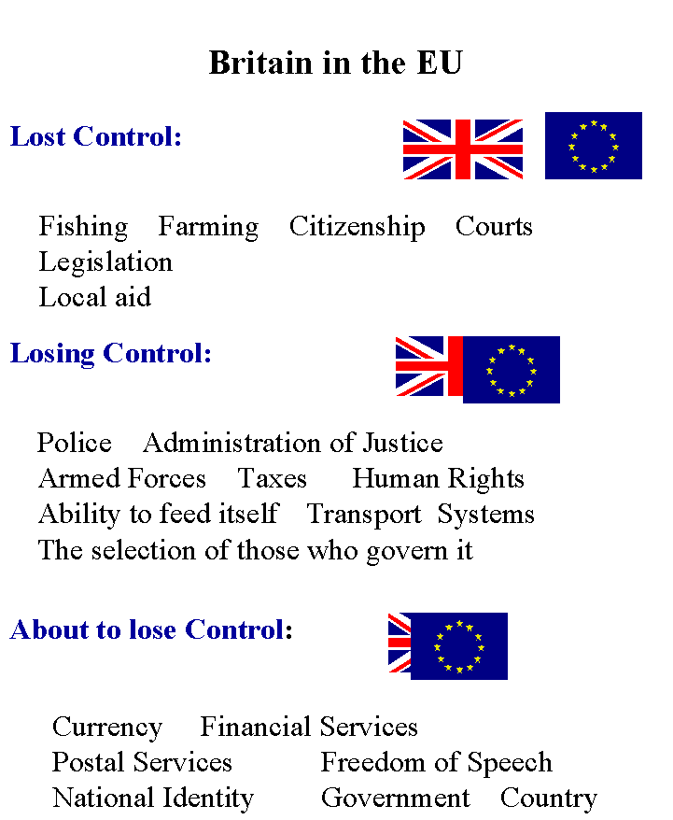
VISUAL AID – NUMBER ONE:
VISUAL AID - NUMBER TWO: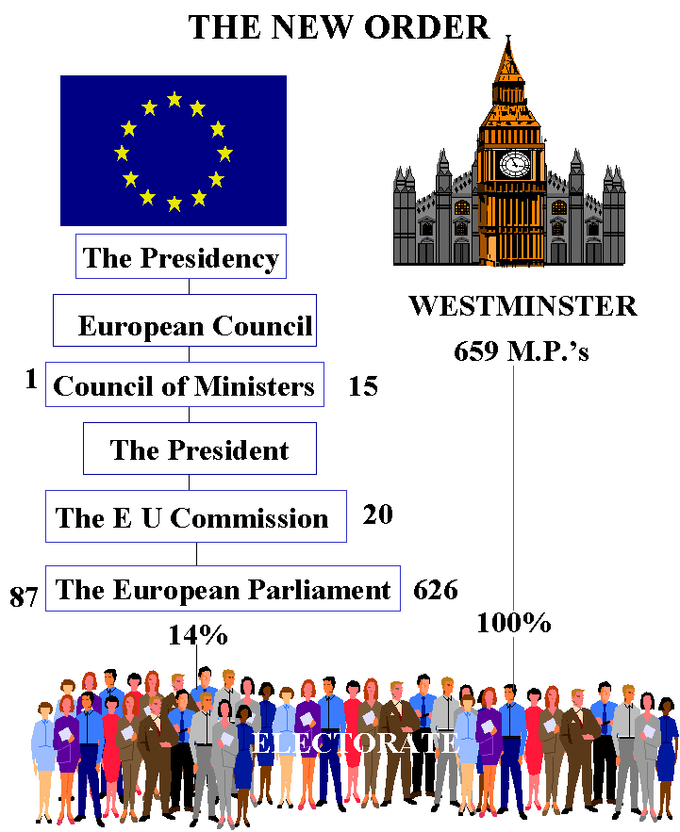

VISUAL AID - NUMBER THREE:
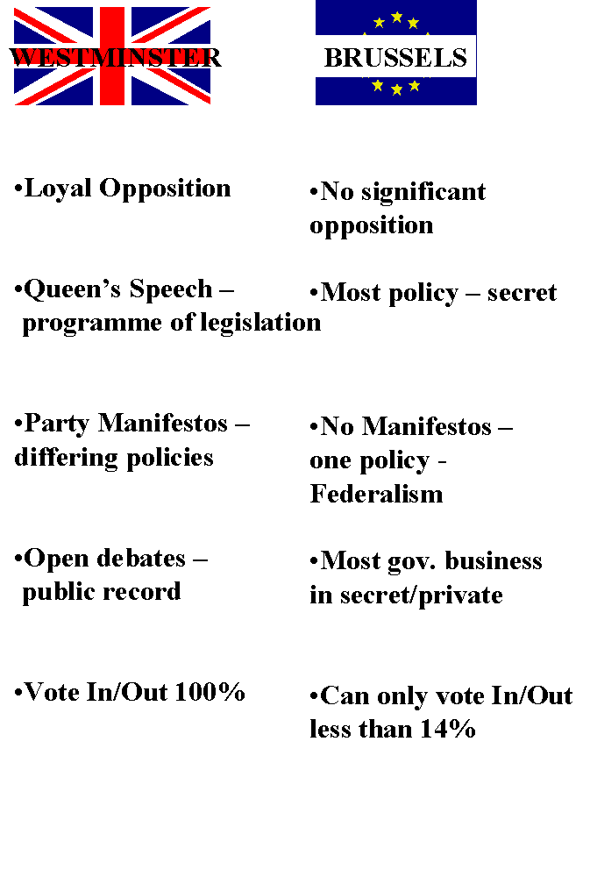
VISUAL AID - NUMBER FOUR: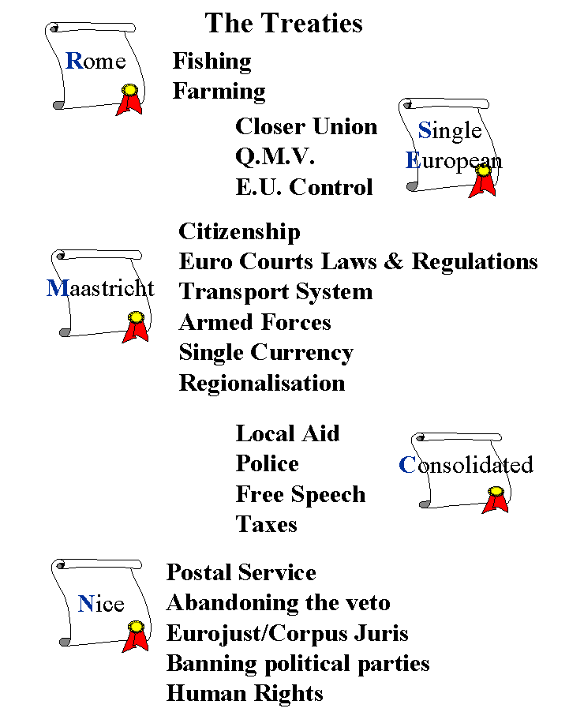
VISUAL AID - NUMBER FIVE: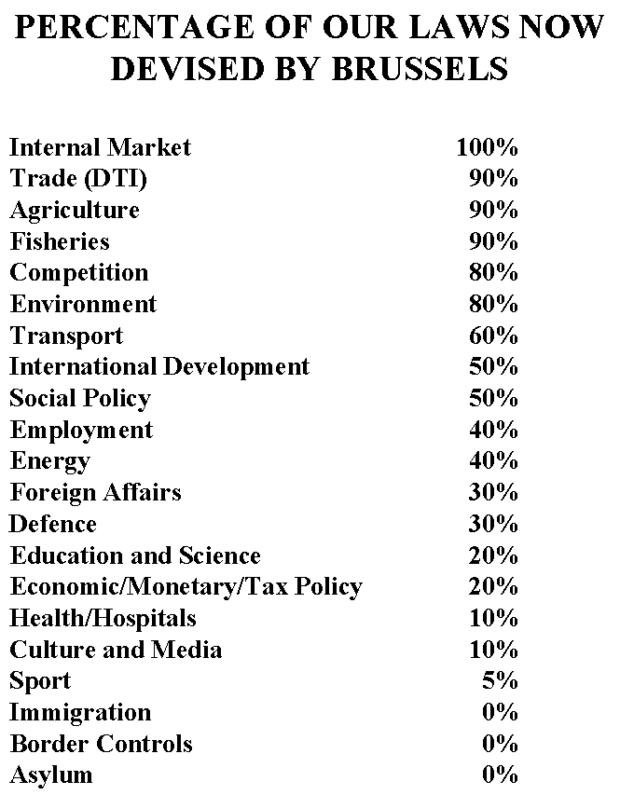
VISUAL AID - NUMBER SIX: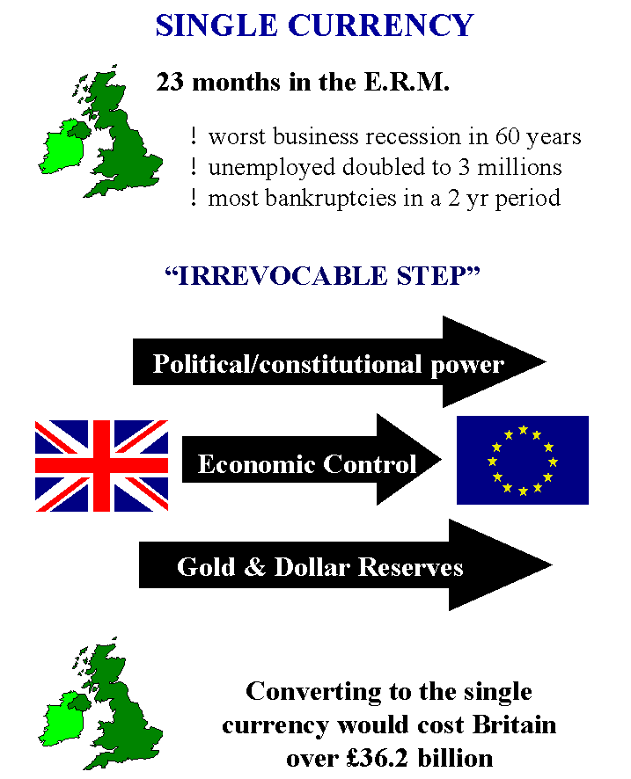
VISUAL AID - NUMBER SEVEN: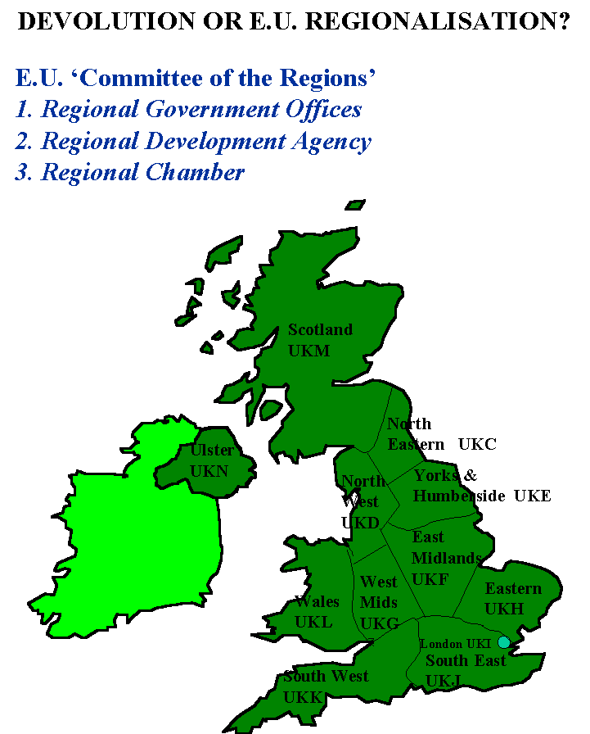
VISUAL AID - NUMBER EIGHT:

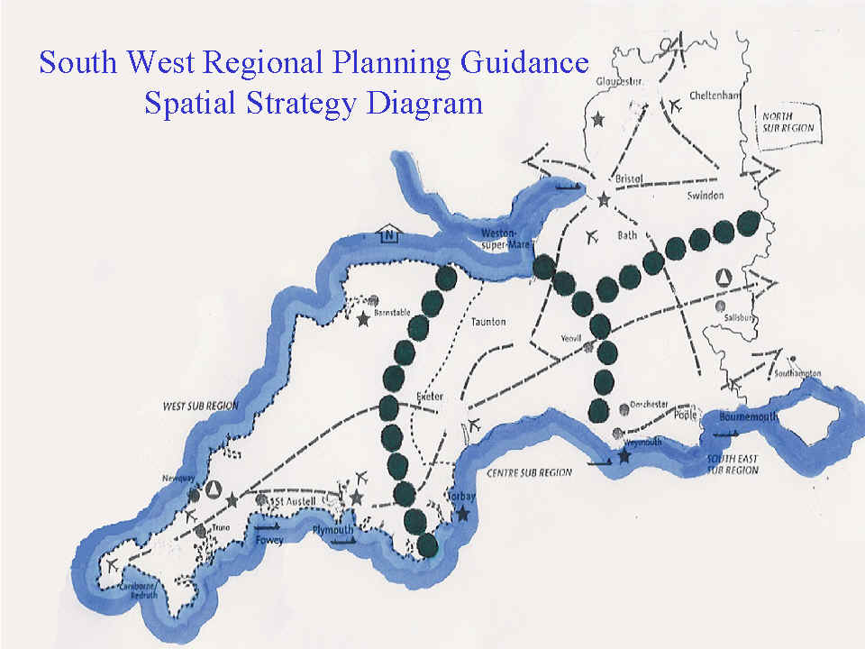
VISUAL AID - NUMBER NINE: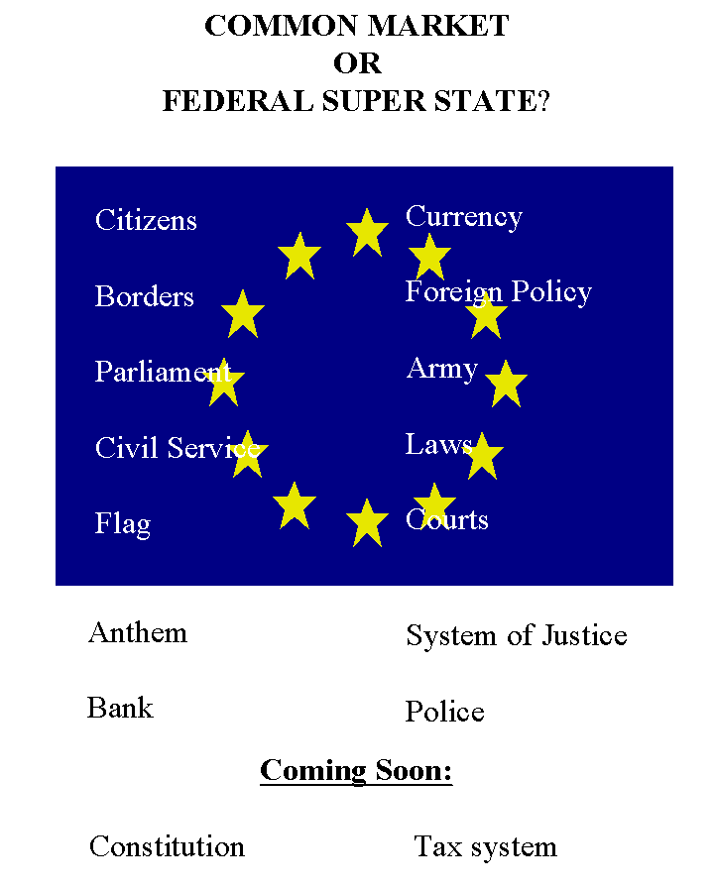
VISUAL AID - NUMBER TEN: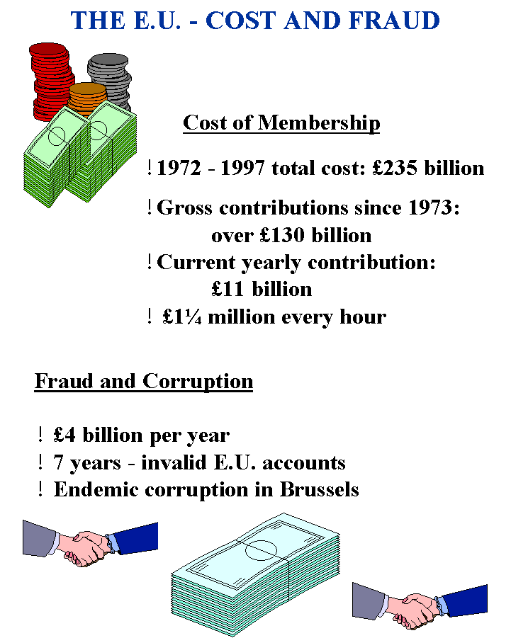
VISUAL AID - NUMBER ELEVEN: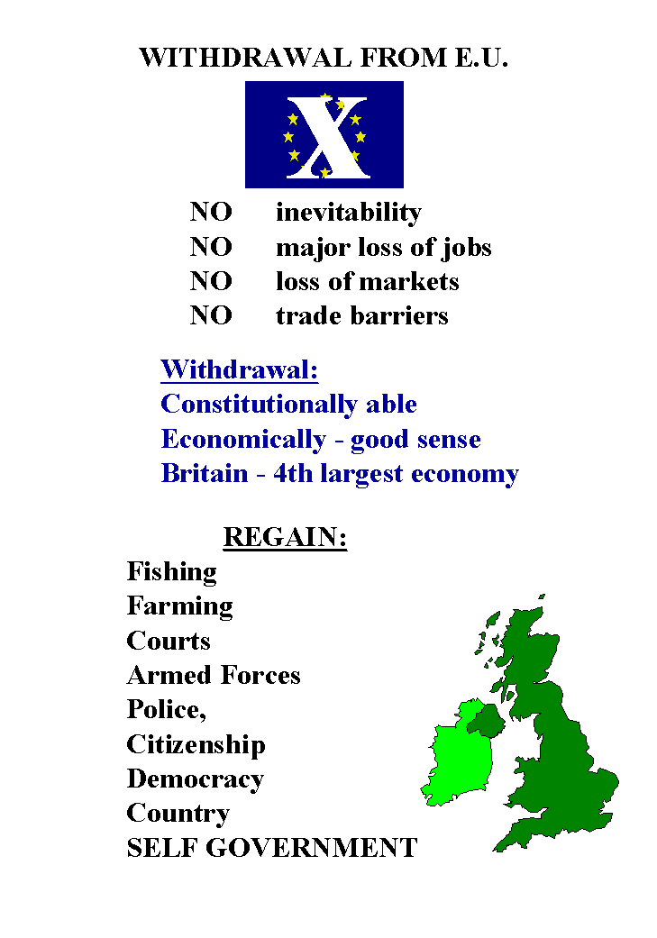
AND NOW SOME HELP DATA:
Tips to be Aware Of as:
The ‘Speaker’

Be Aware That:
You will meet people who will:-
Dislike the truth and show it
Ridicule you
Disrupt you
Ignore you
Challenge you
Express contempt for you
Undermine you
Walk out on you
Hate you
The other 95% are less ill mannered and will welcome you and wish you well !

Before you start:-
Know your subject thoroughly
Know your equipment thoroughly
Know everything about handouts/other documents you use.
Practice and time your presentation, continually.
Be aware of your appearance and how you sound.
Wear No political badges
Be up to date.
All this will give YOU confidence &
give your audience confidence in you & the FACTS you give them

Before an engagement:-
Speak to the organiser during the week prior to the engagement.
Practice/time the presentation at least once in the 24 hours prior to speaking.
Check your equipment/materials/package before leaving home.
Always carry an extension lead and a spare bulb.
Leave plenty of time for your trip.
Arrange to arrive 15 minutes earlier than is required.

At an engagement:-
Don’t demand.
It is their meeting/business.
Be flexible, don’t pre-judge either way.
Expect to be nervous, welcome it.
Set up so that you can operate efficiently
(plenty of table space, watch cables, glass of water).
Check from the back row.
Speaking:-
Introduction:
Thank them for inviting you.
Give your name and the fact that you are ORDINARY (like them).
You are not here to represent any political party or organisation.
Not here to say EU is good or bad
Not here to suggest voting for or against any political party.
No party politics at all.
The package is not from a political party it is independently researched and compiled
No opinions or conclusions
Purpose is to pass on factual detail – they can then decide.
Suggest they keep questions until the end.
Text offer (A fiver for the text so a check can be made as to accuracy).
The package
Don’t rush.
Listen to yourself speaking.
Eyeball everyone, don’t miss anyone
In a LARGE hall speak more slowly and for the benefit of those at the back!
Be aware of the nodder.
Deal with questions.
Move around
Keep an eye on the time.
STICK TO THE SCRIPT!!!!
Questions
If you don’t know the answer, say so.
Common questions (see attached list)
Introduce the handout – easily accessible

At the end
Don’t rush away – they will want to talk.
Sell the facts & further meetings as much as possible.
Give personal details (for other talks).
GET personal details (for other talks).
Check all equipment and materials.
Thank your hosts
On the way home critique yourself
Within two days send a letter of thanks.
REMEMBER to offer to give more talks if they can arrange more meetings.

COMMON QUESTIONS
&
SOME SUGGESTED ANSWERS
Q "Are you a member of a political party or organisation?"
A "I am / I am not - but as you will have noticed this entire presentation is not from a political pary or the perspective of a political party. It is independently researched and distribution is by SANITY & The SilentMajority who are not party politically biased, which is why no mention is made of political parties."
Q "Your view of the EU is biased. You haven't given any of the benefits of membership."
A "If you can tell me any significant benefits I should have included please do?"
Q "The EU has kept the peace in Europe."
A (i) "Britain didn't officially join until almost 30 years after the WWII, si I guess obviously Britain played no part in that!"
A (ii) "Which nation do you believe might have started such a war without the EU?"
A(iii) "There is surely a much better argument for the fact that NATO, thousands of troops and the nuclear deterent played a large part in keeping the peace."
A(iv) "Since Britain had nuclear weapons, a strong navy, well equipped air force and highly trained army which virtually no other country in the EU could claim, surely you can not be suggesting the best way to keep the peace is surrender to unelected foreign officials, can you?"
Q "We have gone too far now this is all inevitable?"
A "Nothing in life is inevitable - no one has even asked us what we want yet so we could easily leave."
Q "How do I know you have been telling the truth?"
A "You don't, but then again you don't know what lies you are told by politicians and so called pundits on the media. The difference is that you can easily check every single fact I have given you, you will recal I said that the full text was 'my crib sheet' and had the sources for every single quote and fact - do have a look."
Q "I must think about it because it is only right to hear the other side."
A "You are quite right but of course I would contend that you have only heard the other side for the last 40 years with some very small exceptions - but by all means look closely at the facts and the truth from all angles."
Q "What can we do to stop the EU destroying our country?"
A (i) "Tell other people you know about what you have heard here, help me to organise further presentations like today, obtain all the notes to do presentations yourself from the web site or get copies of the video and make sure lots of people see them."
Q "What is wrong with being in a Federal Superstate. It could be to our advantage and the world moves on?"
A "Sensible as that may sound one has to ask if that is the case why have our own politicians not only lied to us but constantly they have told us for over 30 years that that is definitely what ISN'T happening. In terms of 'the world moves on', indeed it does and the idea of single currencies and centralised super states was a Victorian concept from the 1800s - the USSR proved in the 1900s that as a concept it was a failure in the long run; just look at the misery, bloodshed and starvation that has occurred throughout history as previous Super States have collapsed!"
Q "Where does the Queen stand in all of this?"
A "Constitutionally Her Majesty is in a difficult position: Her Coronation Oath gives a solemn and binding undertaking to 'rule Her peoples according to their ancient laws and traditions': There is no doubt she has broken Her Oath to Her peoples but she would claim that she gave HER assent to EU treaties on the advice of Her Ministers. Her Majesty is in a very difficult position which she has failed totally to resolve!"
Q "The EU is democratic we vote for our MEPs"
A "That is true sir but as you will have seen YOUR MEP has very little influence once voted in. Let us look at the proof of the total lack of democracy - for over 30 years every single prospective MP from every single party has said the EU's CAP is wrong and must be altered. Can you name another single solitary point on which every single politician of every single party has agreed for 30 years - Total Unanimity.
Every British politician who has gone to the EU in ANY capacity has said the CAP must be changed - Absolute cross party agreement for 30 years.
Can you name one single policy of substance in the CAP that they have managed to change?
Perhaps that proves just how dishonest the EU is; when it pretends to be a democracy".
Q "Surely Britain must stay in the EU to influence the future decisions and improve the EU"
A "Firstly sir I would draw your attention to the fact that the EU is NOT a democracy, secondly you would not suggest sharing your house with a man eating tiger on the grounds that you were hoping to train it to be a vegetarian, would you?"
PLEASE if you are regularly asked a question when giving this presentation which we have not included in the help pack, above: PLEASE mail us the Question and we will consider and provide a fully documented Answer for everyone to use.
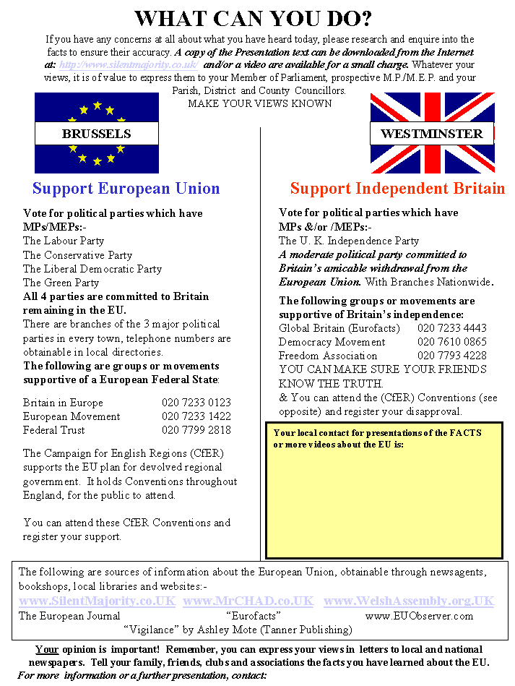

To Obtain the full text, notes & visual aids for this presentation please
COPY this whole file to YOUR computer dependent on how you are connected to the internet this will then take a couple of minutes to transfer to your computer; it comprises around 50 pages of notes and 11 Visual Aids.
Once you are OFF Line you can print the pages at your convenience
There is NO CopyRight on this document, which is one of many 1,000s of items freely available on http://www.SilentMajority.co.UK [some 20Mbs.] & 10s of 1,000s of items on The SilentMajority CD [with over 80Mbs.] which contains the entire web site & hosts other web sites also, 1,000s of apposite quotations, Articles, Speeches, Commentaries, ArtWork, & The FULL text of The EU Treaties, Several Related Books, The British Constitution, The American Constitution & Numerous related Items.
SilentMajority nor any associate thereof does NOT vouch for the veracity of the documents hosted on its site or CD nor any foreign language documents thereon & advises you consult your own solicitor on legal details as we do not accept liability for, nor presume to give legal advice ourselves.
For a copy of the CD please mail payment of £20.00 for UK deliver or £25.00 for ALL other Countries payable to:
Greg Lance – Watkins,
Glance Back Books,
17 Upper Church Street,
CHEPSTOW,
NP16 5EX
Monmouthshire,
GREAT BRITAIN
For delivery of 2 x CDs
one for your own use
+ one for on selling or donation to an individual of influence (media, politician, activist etc.)

TAG DATA:
for your information - Follows:
Good luck & if I can help you in your efforts in defence of the British peoples and our Nation or the rights and freedoms of any peoples, against the EU, NAFTA, WTO, IMF, OWG, NWO or the Regionalisation Policy, designed to break up YOUR Country on a divide and rule basis etc.
Please just ask.
Do visit our shop, if you are ever in the area. We are open from 10.30ish. till 5.30pm. 6 days a week.
Greg Lance - Watkins,
Cynulliad i Gymru [trans.: THE WELSH ASSEMBLY],
c/o Glance Back Books
[second-hand & antiquarian books,
coins, stamps, medals, post cards,
bank notes, antiquarian prints & maps
+ conservation & restoration]
17 Upper Church Street,
CHEPSTOW,
NP16 5EX
Monmouthshire,
GREAT BRITAIN.
'e'mail: Greg@GlanceBack.Demon.co.UK

FOR YOUR INFORMATION:
I apologise for the length of this 'tag' but since THIS MAY WELL BE passed on both, Nationally & InterNationally, also posted to various Web
Sites I am sure you will accept the inconvenience in support of the distribution of the truth and the defence of Britain & freedom.
Do Visit Our Web Site:
<http://www.WelshAssembly.org.uk>
ALSO DO Visit the Web Sites:
<http://www.SilentMajority.co.uk>
Do Make a point of viewing the LINKS page which links to all the major EU related pages.
This entire Web Site is 'mirrored' on:
www.EUroRealist.co.UK
should you experience any difficulty in contact, due to either interference with the site or ISP problems.
&
www.MrCHAD.co.UK
Mr. CHAD has come out of retirement after 55 years & with his friend KILROY will once again be defending Britain
Or For: DIARY UP DATES:
www.SilentMajority.co.UK/EUrorealist/Diary-Updates.html
& for
FOOT (HOOF) & MOUTH DISEASE
For The IMMEDIATE Legal Data & HELP for FARMERS
<http://www.FMGroundForce.co.UK>
for the largest British based resource & data web site see:
<http://www.SilentMajority.co.UK/FootInMouth>
ALSO:
A CD of the entire site, which now runs to around 1,500 pages and about 20MBs, is available, for viewing 'Off Line',
the CD includes a mass of reference material in addition to that which is on the Web Site and thus now runs to over 80MBs.
Including the full text of:
the main EU Treaties, The British Constitution, The American Constitution and amendments and the full texts of several books.
The CD also includes:
The whole of several other Web Sites, such as:
The Committee to Restore the Constitution (USA), What Are We Swallowing, The Welsh Assembly, The Bilderbergers.

Do SnailMail Twenty Pounds (British), payable to me personally, to defray costs, for TWO copies of this CD
[1 for you to resell or give to a friend]
ALSO VIEW:
www.SilentMajority.co.uk/EUroRealist/onthespot.html
BBC 'On The Spot' programme - a debate on leaving the EU
Greg Lance-Watkins
vs.
Jonathan Evans MEP[Cons.],
Huw Richards President N.F.U. Cumri,
Carl Handley Chairman of Wales in EUrope
&
METRICATION a full legal 'Opinion'
<http://www.SilentMajority.co.uk/EUroRealist/Weights>
&
CHALLENGE to Politicians of Stature
<http://www.SilentMajority.co.uk/EUroRealist/Challenge.html>
&
CULLEN Dunblane Cover-Up
<http://www.SilentMajority.co.uk/EUroRealist/Cullen>
&
**********************************************
PETITION to Her Majesty The Queen:
www.SilentMajority.co.UK/EUroRealist/OurMonarch
**********************************************
&
CITIZENSHIP & YOUR Legal Position:
www.SilentMajority.co.UK/EUroRealist/OurMonarch
&
DEFENCE OF THE REALM
www.SilentMajority.co.UK/EUrorealist/MagnaCarta
or
www.SilentMajority.co.UK/EUrorealist/MagnaCarta/index.html
&
MISPRISION of TREASON
<http://www.SilentMajority.co.uk/EUroRealist/TreasonAct1795>
<http://www.Studio71.co.UK/TreasonAct1795> [for the photos]
NEW WORLD ORDER - Chronology
<http://www.SilentMajority.co.uk/EUroRealist/NWOchronology>
&
<http://www.geocities.com/ResearchTriangle/Facility/4213/essgl1.html>
&
The 2001 CENSUS
<http://www.SilentMajority/EuroRealist/CENSUS>
&
Save the Pound Petition
<http://www.SilentMajority.co.uk/EUroRealist/Petition.html>
&
View the latest Political Dinosaur at
<http://www.SilentMajority.co.uk/EUroRealist/EUrassic-Park>
Extinction imminent
&
~~~~~~~~~~~~~~~~~~~~~~~~~~~~~~~~~~~
"To achieve One World Government it is necessary to remove from the minds of men their individualism, their loyalty to family traditions and national identification."
Brock Chisholm, when director of UN World Health Organisation

DO PASS ON any information you may receive, which you feel may help in defence of Freedom.
If you have a friend or associate who you feel could help in our campaign, please send me their 'e'mail address, name
and preferably their street address also.
DO CONSIDER joining:
EUroRealist@SmartGroups.com <mailto:EUroRealist@SmartGroups.com>
to join in a wider conversation. Join now by sending blank e-mail to
eurorealist-subscribe@smartgroups.com <mailto:eurorealist-subscribe@smartgroups.com>
OR
if you have ideas or concepts where you could help or you need help PLEASE do contact me.

IF YOU wish to use the Material Above, which is freely provided
Please have the Courtesy to Print It out in its entirety from start to finish with NO alterations, as displayed.
To This Point
WE DO HOPE THIS WILL HELP YOU TO UNDERSTAND THE RELATIONSHIP BETWEEN BRITAIN AND THE EU.
ALSO TO FURTHER UNDERSTAND THE EU
&
TO COMMUNICATE THIS INFORMATION TO MANY OTHERS.

